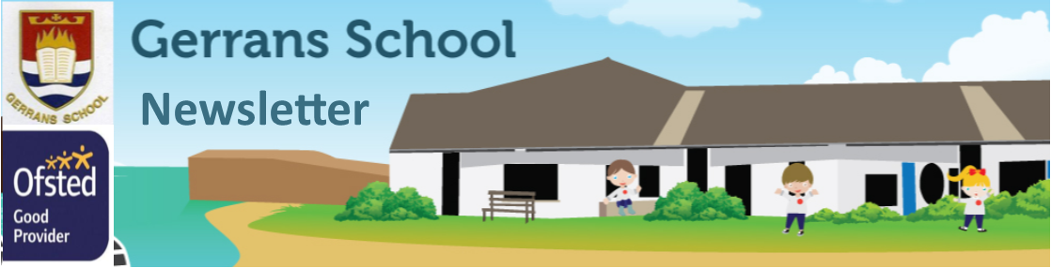

Friday 8th September

Multi Academy Trust
Our Mission, Vision and Values
Mission: The Roseland Trust provides outstanding education for our communities, where everyone succeeds.
Vision: To inspire a love of learning within environments that are happy, respectful and challenging, where everyone feels valued and able to reach their full potential.
Values: Kindness, Ambition, Responsibility.
Gerrans Very Golden Values
We are Gentle and kind
We Encourage each other
We have lovely time visiting We Respect others and property
We are Resilient learners
We are Always truthful and trustworthy
We are a Nurturing environment
We are Supersonic

Respectful, Responsible and Resilient
Dear Parent(s)/Carer(s),

Welcome back to the new school year; I hope you had a lovely summer break with friends and family (despite the weather!) You will have noticed that we have welcomed some new faces to our school team this year and that, as our school has grown, we have been able to add an additional KS2 class. It has been a pleasure to see the children settling back into school life; it has been lovely to see them so excited to greet their friends. We are looking forward to a busy and exciting year ahead. Next Friday morning, we are holding a meet and greet session to which you are all invited. This event will be held in the school hall and it will be an opportunity to meet the school’s leadership team and to ask any questions you may have about school life.

Kate Douglass and Matthew Richards
Executive Headteacher and Deputy Headteacher

Towan Class News

Towan Class has had a super start to the new school year and it has been really pleasing to see the positive attitudes and enthusiasm from everyone. We have enjoyed getting to know each other again, and sharing our aspirations for the year ahead.

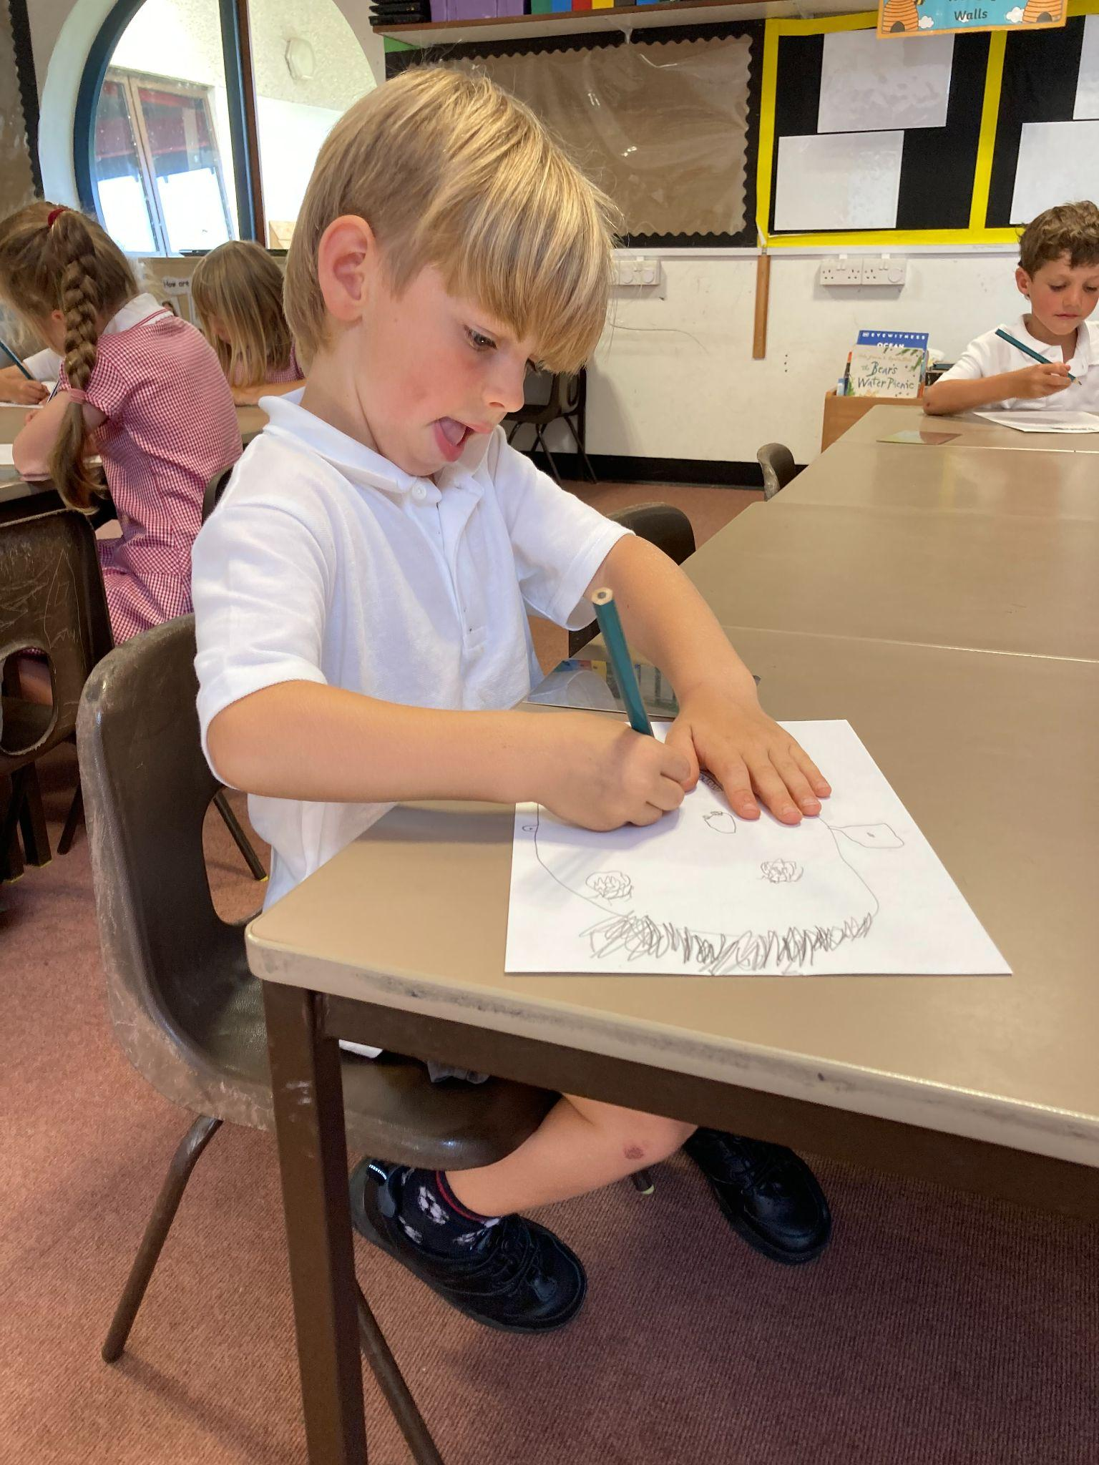
The children have embarked on their first Talk for Writing story, The Three Little Pigs, and have re-visited some previous learning in Maths ahead of the first focus - Place Value. The children spent time studying themselves in mirrors in order to produce self-portraits using only soft artist pencils.

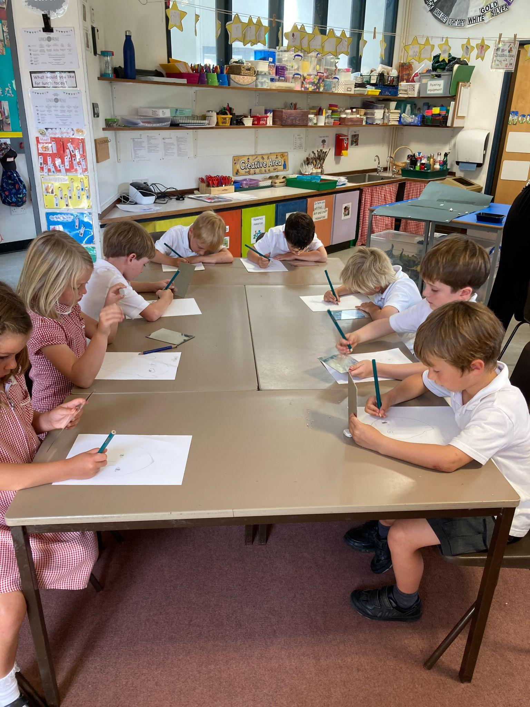
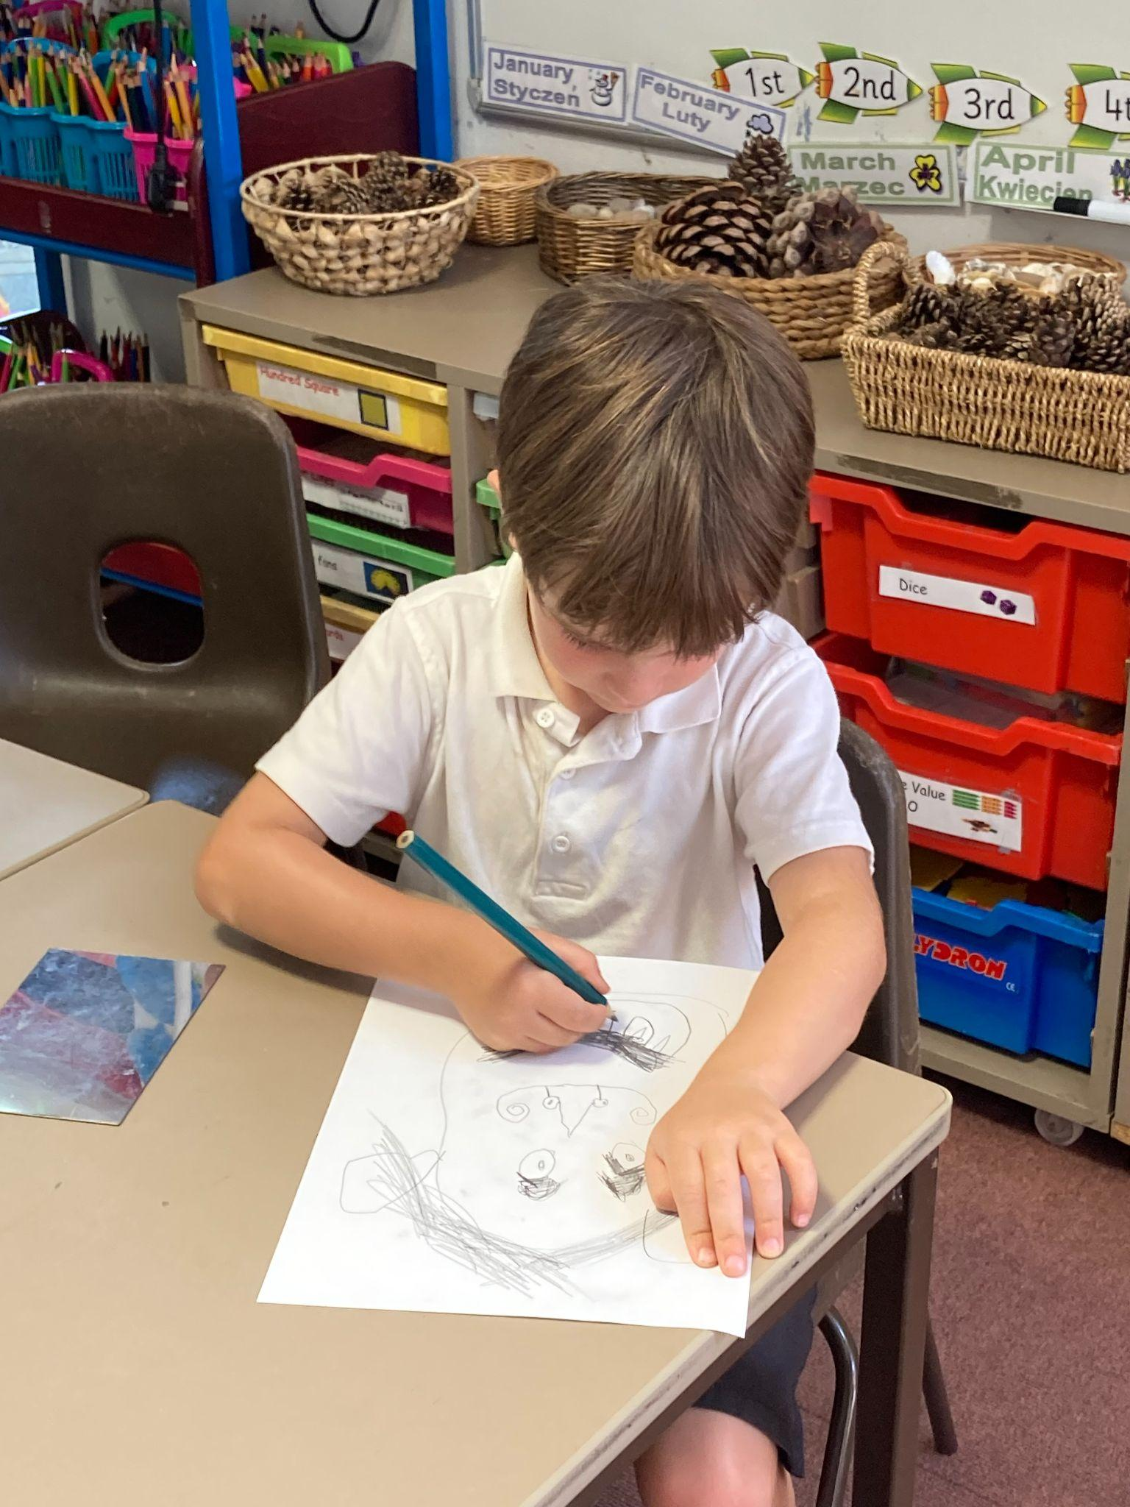

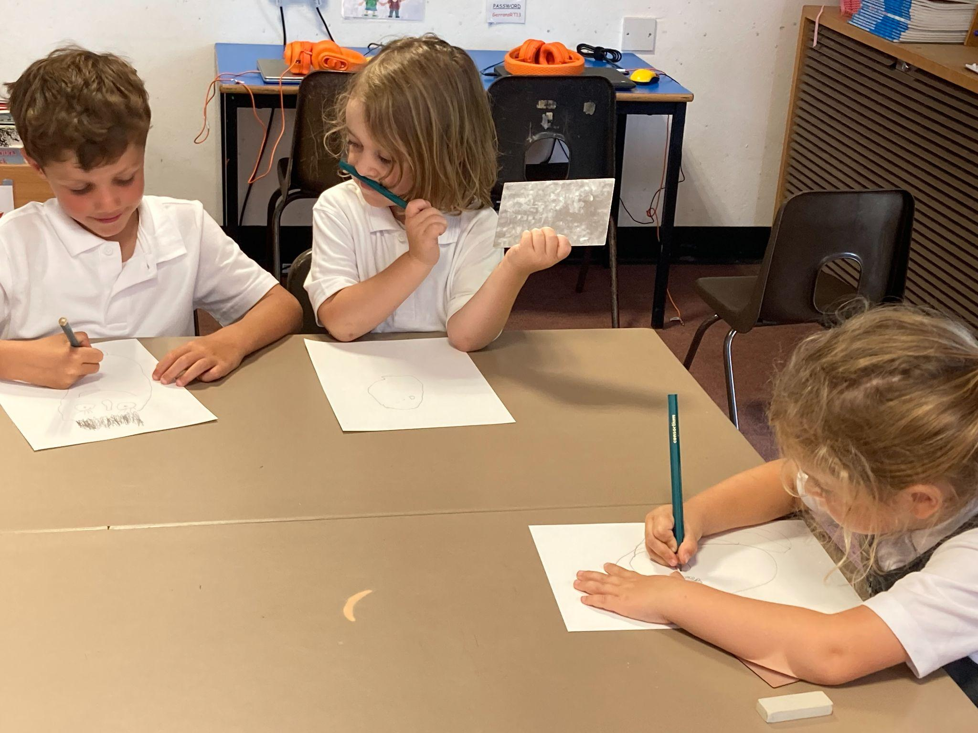

Porthcurnick Class News

Year 5 and 6 have had a great start to the new academic year. The children have embraced new and old routines and are making every effort in their learning. In maths, we are learning about place value - year 5 have focused on Roman numerals while year 6 are reading and writing numbers up to 10,000,000. In English, we are enjoying our class novel - The Boy in the Tower by Polly Ho-Yen. In history, we have begun a unit on the Tudors, looking at whether Henry VIII was a fair ruler or a tyrant, using primary and secondary sources of evidence. In PE, we have started a gymnastics sequence unit. Children are bringing home a banded reading book and a free choice library book today, as well as their spellings to learn for next week’s test.

Pendower Class News

What a terrific start to the Autumn Term! It has been an absolute delight to see everybody settle back into our routines with smiles on their faces.
This week, we have taken a deep dive into the global issue of plastic pollution in preparation for our Talk for Writing text, The Lost Whale by Hannah Gold. Pendower children have written a poem about their memories of the sea and performed it in assembly as well as presenting our fundraising ideas for Surfers Against Sewage to Mr Richards . We have also recycled a huge wave of rubbish which washed up in our classroom! Categorising and recording the materials to recycle took careful consideration before we were able to analyse the data from the bar charts we created.
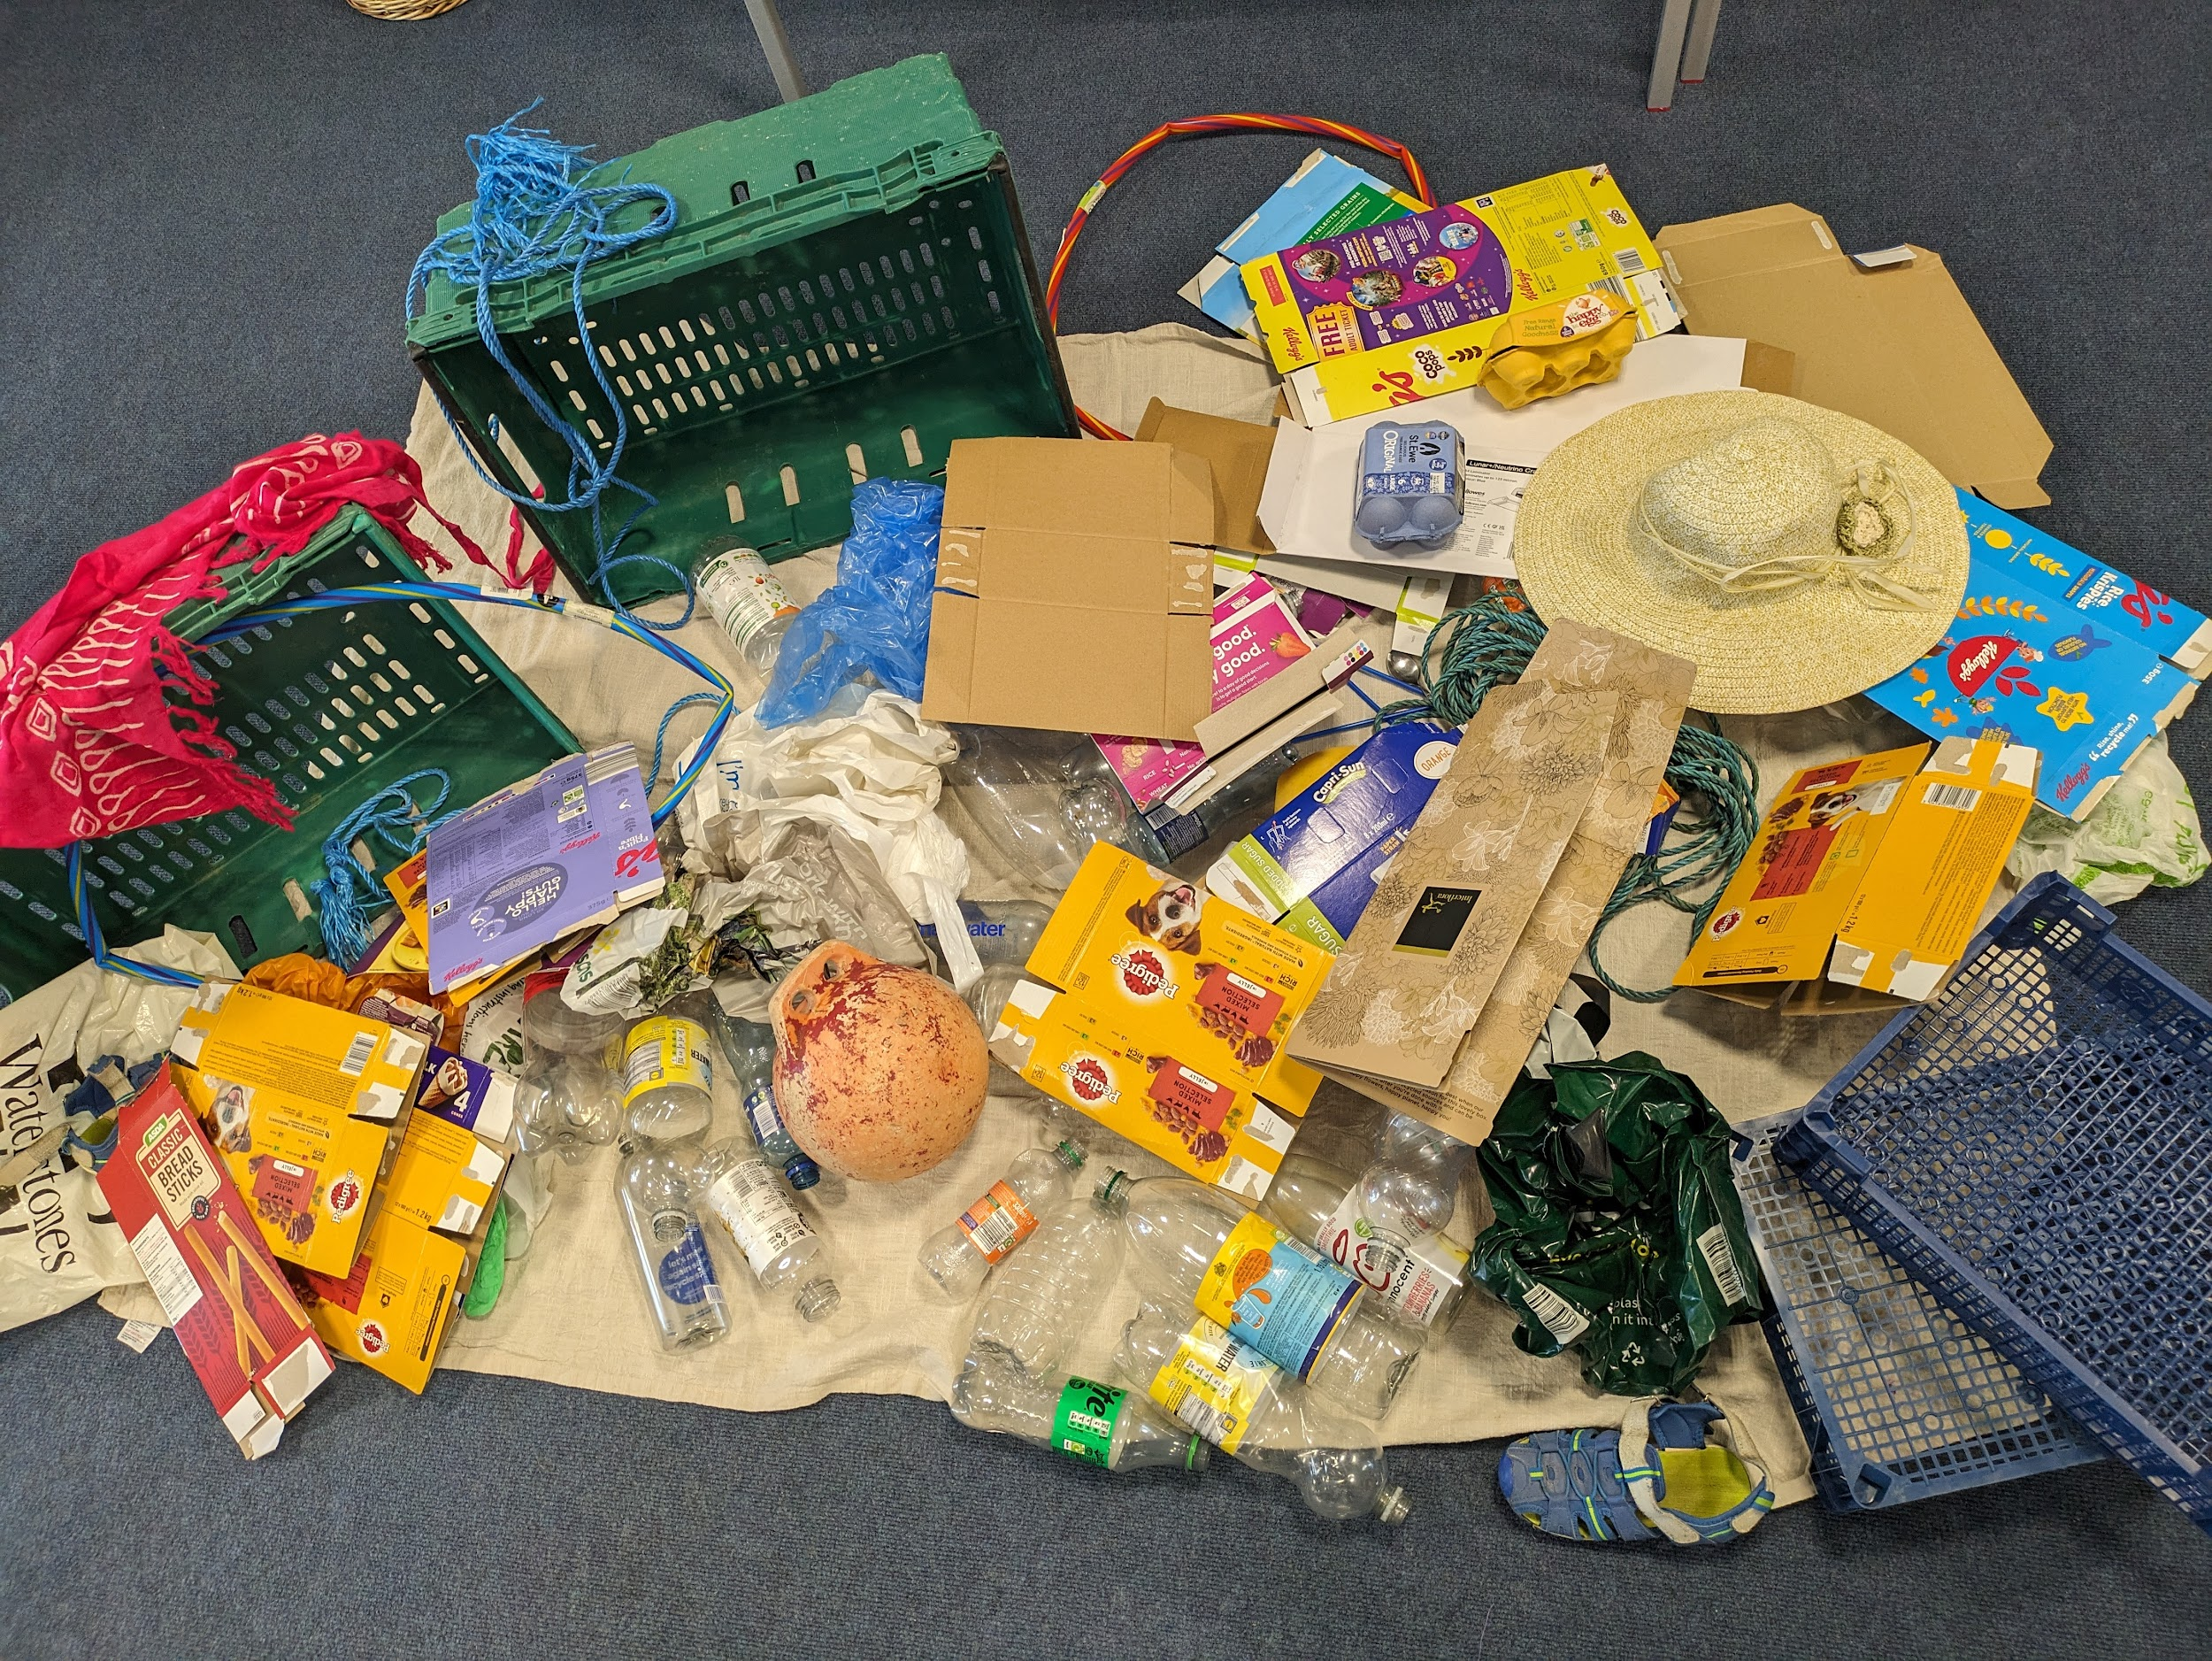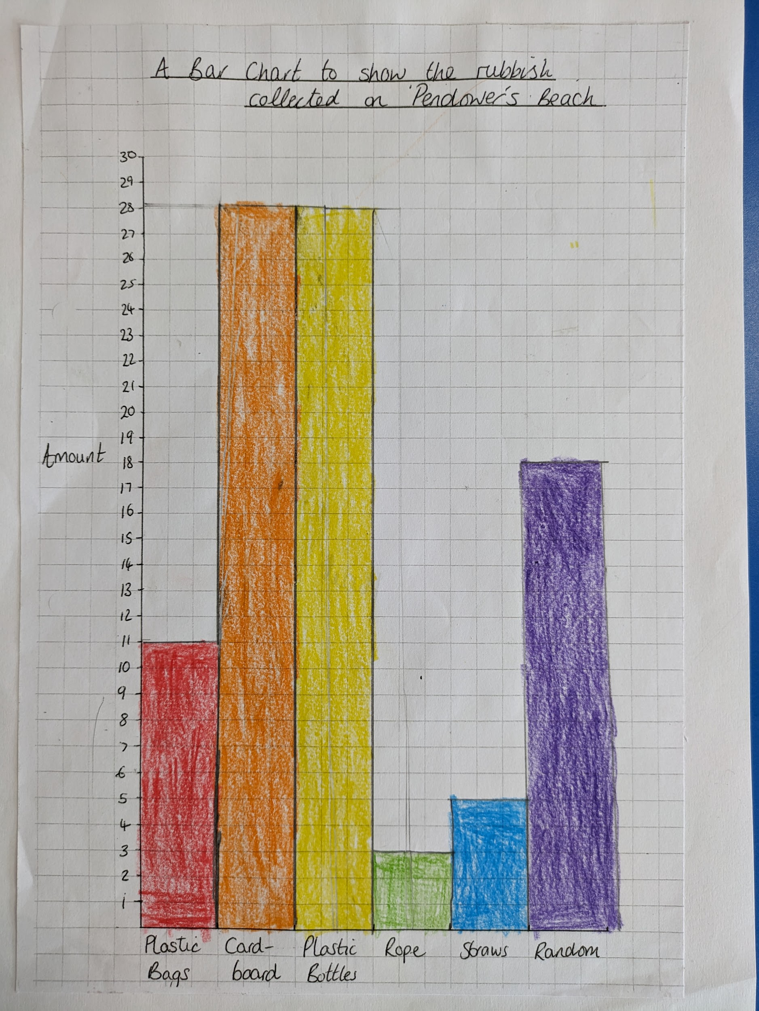

Towan - Oscar Palmer for a positive start to the new school year.
Pendower - Jaxon Crouch for quickly learning our class routines and listening to instructions & Esme Zimmerman for quickly learning our class routines and always striving to do her best.
Porthcurnick - Kyle Hillyard for effort, enthusiasm and knowledge in History.
Tatams -  Towan -  Porthcurnick - | Breaking news!  This year, we have decided to rename our school houses and to reallocate children to these. The children have come up with possible names and today we are going to vote on which names we would like to use. We will also introduce house captains for our house from our older year groups.
- Whole School Letter  - Class Letters  - KS2 Art Club | Pendower: : 98.3%  Towan : 95.8%  Porthcurnick: 98%
White band (15 reads) -  Yellow band (30 reads) -  Orange band (50 reads) -  Red band (70) - | Purple band (95) -  Green band (120) -  Blue band (150) -  Black band (180) -
Please see the link below for our latest online safety newsletter and up-to-date guidance on how to stay safe online.

https://www.nspcc.org.uk/keeping-children-safe/online-safety/
ttps://my.newzapp.co.uk/t/click/1615960114/113430205/1673ab.pdf

Inset Days for 2023/24

- Monday 22nd July
- Tuesday 23rd July
- Wednesday 24th July

Diary Dates
Tuesday 12th September - Read Write Inc Parents Information Session - 3.30pm
Friday 15th September - Meet & Greet with Mrs Douglass and Mr Richards ~ 9.15am - 10am - All Welcome
Friday 22nd September - Meet & Greet with Mrs Douglass, Mr Richards and Laura Read ~ 9.15am - 10am - SEND Parent(s) & Carer(s).
Friday 19th July 24 - Last Day of Summer 24 Term
New Office Email & Staffing
Monday & Tuesday - Ashley Dredge
Wednesday, Thursday & Friday - Tracy Hooper
For general office enquiries please can you use the following email address:-
gerrans-reception@gerrans.cornwall.sch.uk

School Uniform
We do have some sweatshirts in stock( selected sizes), please see Mrs Hooper.
Online orders via :-
https://www.schooltrends.co.uk/uniform/Gerrans_Primary_School_TR2_5ED
School Dinners

Please check your School Gateway for balances, any unpaid balances from last year have been brought forward.

Free School Meals
Find out if your child can get free school meals, how to apply, and understand how to get extra funding for your school.

Pre-school children aged 2, 3 and 4 (not yet in a reception class)
Your child will be eligible for free school meals if they meet the eligibility criteria and attends:
- the nursery class of a school/academy
To be eligible for a free school meal, your child will need to be attending sessions before and after lunch on that day.

Children in Reception, Year 1 and 2
All Key Stage 1 (Reception, Year 1 and Year 2) pupils are entitled to receive a free school meal. This is part of the Universal Infant Free School Meals (UIFSM) initiative and regardless of what benefits are being claimed.
However, some children in Reception, Year 1 and Year 2 may also have an entitlement to benefits-related Free School Meals. Children in this group are also eligible for Pupil Premium – additional funding paid to the school to support your child in their learning. It is important to apply for benefits-related Free School Meals if you think your child may be eligible. This is so that your child’s school can receive this funding.
Your child will be eligible for benefits-related Free School Meals if you meet the eligibility criteria.

Children in Year 3 and above
Your child may be eligible for benefits-related free school meals if you, or the child themselves, meet the eligibility criteria.
If eligible for Free School Meals, your child will also be eligible for pupil premium. This is additional funding paid to the school to support your child in their learning.

Free school meals eligibility criteria if you receive benefits
A child is eligible for free school meals if their parent/carer (or the child themselves) receives any of the following benefits:
- Universal Credit (provided you have an annual net earned income of no more than £7,400, as assessed by earnings from up to three of your most recent assessment periods).
- Income Support (IS)
- Job Seekers' Allowance (Income-Based) and equal based Job Seekers Allowance
- Income Related Employment and Support Allowance (ESA-IR) and equal based Employment and Support Allowance
- Child Tax Credit (CTC) with an annual income of less than £16,190
- Working Tax Credit run-on - paid for 4 weeks after you stop qualifying for Working Tax Credit
- Guarantee Element of Pension Credit (GPC)
- Immigration and Asylum Act 1999 (IAA) Supports
If you are claiming the benefits listed below you are not eligible for free school meals. This is regardless of what other benefits/credits are being claimed.
- Working Tax Credit
- Contribution-Based Job Seeker's Allowance and/or Contribution-Based Employment and Support Allowance
There are different eligibility criteria for families who are not entitled to benefits (NRPF - No Recourse to Public Funds)

Free School Meal transitional protections
The benefit related free school meal (FSM) protections policy was introduced in 2018 to protect those eligible for benefit related FSM from becoming ineligible while Universal Credit (UC) is being rolled out. This was originally set to last until March 2022 and was subsequently extended to March 2023.
The end date for protections has now been extended further until March 2025. This is when we expect UC roll-out to be complete for most cohorts.
This means that a pupil who was benefit related FSM eligible on 1 April 2018, or who has become eligible under the benefits/low-earnings criteria since then, will continue to receive free meals, even if their household income exceeds the eligibility threshold, up until March 2025 and then until the end of their phase of education.

