‘

Marking and Feedback Policy
The main aim of this policy is to support all staff to successfully and consistently support all pupils’ next steps in learning, by the provision of useful feedback.
Feedback/ Marking is completed to move pupils on in their learning and to aid the teacher in assessing the progress and attainment of pupils. The best evidence that quality feedback is being given to children, is the progress that children make over time.
Key Principles:
This policy recognises that the key principle which underlies effective feedback for pupils is the need to celebrate the things which children can do well, and support with the development of aspects which require improvement.
Purpose of our feedback policy
- To support all types of learners to recognise where they are being successful and where improvements can be made (both independently and with adult support).
- To provide a regular form of tailored communication between the adult and pupil.
- To provide precise feedback on how a pupil’s work matches with intended outcomes.
- To provide specific models/suggestions of improved ways of working.
- To provide opportunities for pupils to make improvements to their work both in the lesson and in subsequent lessons.
- To develop supported and independent skills of reflection and review, including peer feedback as appropriate.
- Any feedback including marking should make a difference to the pupil. If it doesn’t (e.g. the use of generic praise comments) then there is no need for it to be written.
Feedback in practice:
It is vital that teachers evaluate the work that children undertake in lessons, and use information obtained from this to allow them to adjust their teaching. Feedback occurs at one of three common stages in the learning process:
- Immediate feedback – at the point of teaching/learning during a task. This is often verbal and is sometimes called ‘on the go marking.’
- Summary feedback – at the end of a lesson / task.
- Review feedback – away from the point of teaching – usually at the start of the next lesson in that subject.
The stages are deliberately numbered in order of priority, noting that feedback closest to the point of teaching and learning is likely to be most effective in driving progress, especially for younger pupils. As a school, we place considerable emphasis on the provision of immediate feedback. Where feedback is based on review of work completed, the focus will often be on providing feedback for the teacher to further adapt teaching.
The primary methods of giving feedback at the school will follow the procedure below:
- Immediate feedback is given within lessons so that children’s knowledge and understanding is secured as the lesson progresses.
- The teacher will review the work completed by pupils.
- Praise and share.
- Need of further support.
- Notes on presentation.
- Basic skills errors.
- Common misconceptions and notes for the next lesson.
Where appropriate, key issues for all children will be fed back at the start of the next lesson (in the form of whole-class feedback) and an opportunity will be given to correct errors or to improve work. Edits, corrections and amendments will be made by the child in a purple pen. Children who need more bespoke support will get this from classroom adults.
No annotations or comments are expected in the child’s book – these will be at the discretion of the teacher. These should be kept to a minimum so that staff can focus their time and energies into lessons and learning activities that meet the needs of children and those that take their learning forward.
Feedback & assessment:
All feedback should contribute to formative assessment and should feed directly into short term planning in order to respond to current needs.
Peer and self-assessment will be used to give children the opportunity to reflect on their own successes and areas to improve and to help to provide that feedback for others.
Feedback that is verbally completed with the child is encouraged – especially while the children are working – so that the child can make an immediate change/correct a misconception. There is no need for the verbal feedback to be written in full but some markings may be made to support the feedback if teachers wish to do so. Staff are actively encouraged to use ways of giving feedback that works for them and their class – aiding them to maintain a healthy work life balance.
Foundation Stage:
In Foundation Stage, the main form of feedback for children will be via verbal interactions. Adults will seek to build children’s confidence and understanding by responding to the significant things which children do or say. Verbal feedback can serve to highlight the positive aspects of children’s contributions and to suggest other ideas and ways forward.
Key Stage 1:
Children in key Stage 1 will be supported to improve their own work and correct their mistakes by class adults in small groups. As much feedback as possible should be verbal. Through Year 1, children will be introduced to self and peer assessment and will be supported to use this in their own and their peers’ work. These criteria should be tailored to the age and targeted improvements for a child. The importance of precise verbal and written feedback which children can respond to during the lesson is a key strategy for securing progress.
Key Stage 2 Self and Peer Feedback:
From Y3 children, pupils will have developed a secure understanding of the importance of using verbal and written feedback in order to confirm what they are good at and what requires improvement. It will be vital to continue to reinforce the message with children that work should show evidence of improvement as a result of verbal feedback, marking and self reflection. Progress and improvements should be particularly celebrated and rewarded. Peer / self assessment criteria should be used regularly to support the learning and understanding of what is required. These criteria should be tailored to the age and targeted improvements for a child.
Marking Codes:
Attainment
B = Below
WT= Working towards expected level
EX= Working at expected level
GD = Working at Greater Depth
Effort
1 – Excellent
2 – Good
3 – Satisfactory
4 – Poor
Pink: for correct answers (a pink highlighter should be used).
Green: for incorrect (a green highlighter should be used) and corrections made close to the error in purple pen.

Note: Attainment grades will be used for key pieces of extended writing in English books. In maths, they will be used for end of unit checks. Effort grades will be placed on all pieces of English writing and maths work. Attainment grades and effort grades will be used once-weekly during our reading routine: on the weekly comprehension task.
Mathematics:
In mathematics, the success criteria will always be displayed on the teaching slides and steps to success will be used as needed. Feedback in mathematics will provide regular confirmation of where children are achieving correct responses. Modelling of preferred strategies may be included as needed for individuals. Self-assessment in maths by giving children the correct answers at the end of a piece of work is encouraged.
You will see:
- Daily marking
- The date written at the top of the piece of work.
- Attainment grades will be recorded on children’s work in pink pen.
- WALT to be typed on the top of worksheets if worksheets are used. Workbooks do not require this.
- Success Criteria will be displayed on teaching slides
- Correct work will be dotted in a pink highlighter.
- Incorrect work will be dotted with a green highlighter.
- All interventions must be in books with the short date
- Adults will mark whether work was supported using an ‘S’. If there is not an ‘S’, work was completed independently
- Green comment written when appropriate – e.g. have you got them? Check your answer here.
- Purple pen is used by children to make corrections/amendments to work
English:
Detailed feedback in English will be completed where most appropriate. Feedback will also be given, via verbal feedback, quality peer or checked self-assessment. The piece of work marked in detail may be referenced through teacher’s jottings and comments in the child’s book in green pen.
You will see:
- WALT to be typed on proforma sheet with book or image included.
- Success Criteria to be typed on the WALT where appropriate. Checklists may also be used as outlined in our writing journey.
- The short date will be written at the top left hand corner of the page.
- Incorrect spellings of words that children should know, should be identified with a green dot (highlighter). Where appropriate, the correct spelling will be written correctly (in green) in the margin and written twice by the child (in purple pen).
- A pink dot will highlight where the child has succeeded e.g. they have correctly used a fronted adverbial.
- A green dot will draw a child’s attention to where a change needs to be made.
- Green comment written when appropriate changes or next steps need to be identified.
- Purple pen is used to make corrections/amendments to work
Foundation Subjects:
Science, RE, PSHE, geography, history and French:
Hinge-point questions will be used when you reach the point in a lesson where you need to check if students are ready to move on or whether they have understood the main objective of the lesson. This may be a/some multiple choice question(s) that requires pupils to answer to ensure they have achieved the learning focus or to identify misconceptions. These may also be an opportunity for longer, written responses to be included (especially for those children in the older years). These will be marked (using pink and green dots) and written feedback provided if the response is incorrect. Effort and attainment grades are not required in these subjects.

Additionally, in the foundation subjects key errors or misconceptions may be addressed by the teachers. This is especially important in the early years of learning as children work to secure key skills, such as letter formation and the spelling of HFW and CEW.
Music:
- Feedback will be verbal
- There is no marking, evidence of progression is in the form of live recordings.
- We should be keeping a record of children’s understanding of the topic / unit / content taught on a three circle worksheet.
Computing
- Feedback will be verbal
Art/DT:
- Artwork is not marked as it is an individual’s creativity and is subjective.
- Key Stage 2 pupils have sketchbooks to show progression towards a final piece.
- Feedback will be verbal
P.E:
- Feedback will be verbal
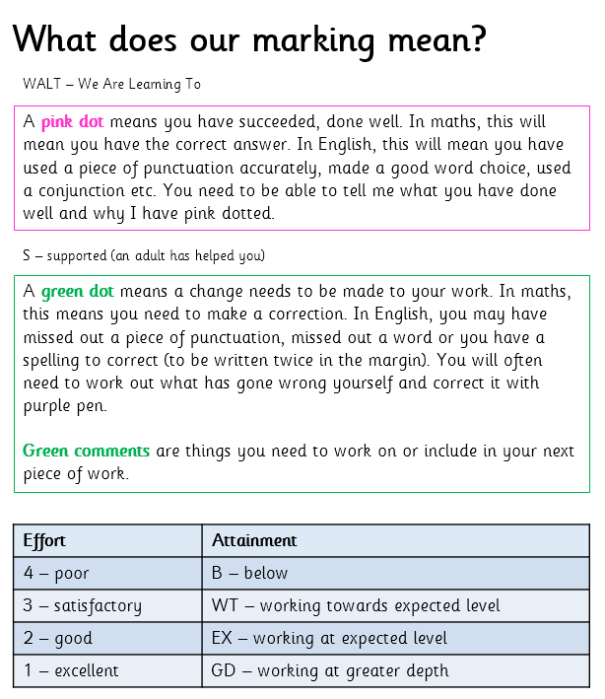

Monitoring Marking:
