Seven Aspects of Reading at Gerrans School

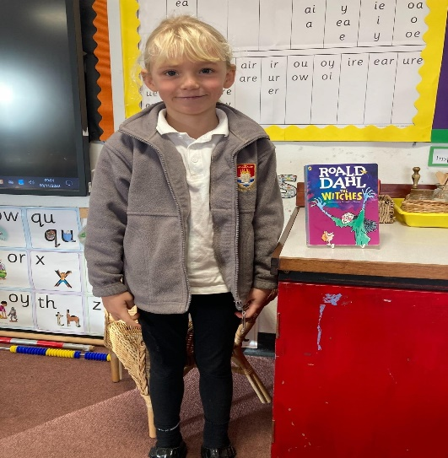
How do we prioritise reading?
At Gerrans, reading is a priority because we recognise that developing both the skills of reading and a love of reading, ensure a world of opportunity for our children. Reading is essential both to access the primary school curriculum and also for the preparation for learning at secondary school. As a skill necessary for life-long learning, it provides endless possibilities and opportunities for improvement and as a pleasure it feeds imaginations and takes us to people and places that we can only dream about.
- Reading is a school priority within our school development plan
- We ensure training and monitoring of reading is in place and it is regularly reviewed.
- The systematic, synthetic phonics programme, Read Write Inc, is delivered daily to EYFS and KS1 between 10.45am and 11.45am.
- Every week KS2 children have opportunities for whole class reading lessons and engage in daily reading comprehension from a range of texts to focus on the VIPERS (Vocabulary, Inference, Prediction, Explanation, Retrieval and Sequencing and Summarising)
- During the course of each and every day, all children are exposed to and have opportunities for many reading experiences: they are read to, they read independently, they read to each other, they read to adults within the whole school community

How do we promote a love of reading?
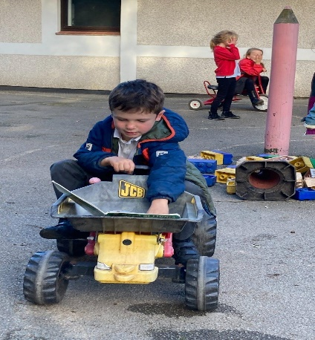
- Staff and children are passionate about reading: we LOVE to read!
- All staff are expert readers, modelling reading skills, discussing texts, reading with children and sharing their love of reading.
- Teachers read class texts daily (both linked intrinsically to the current topic and a book just for fun) to promote a love and enjoyment of stories and other genres. All staff are encouraged to share their own love of reading by engaging in conversations with children about favourite books, authors and different genres, and frequently read to different classes.
- The recently updated school library is regularly restocked, and children are involved in the selection of new reading books, supported by our designated librarians. Children access the library during the week in curriculum time but are also encouraged to visit after school with their families. Gerrans School also runs a Library Book Club! Ways to make the library enticing are always being considered: an outdoor area adjacent to and leading from the library is currently planned. Here children will be able to engage in drama activities as well as have some quiet reading times.
- We encourage children to share their love of reading by inviting them to recommend great reads to their peers, take part in Reading Buddy Assemblies and research activities (paired and individual). They are provided with opportunities to take part in National Events such as Roald Dahl’s birthday celebrations and World Book Day, for reading outside on the playground or in other areas around the school (both inside and outside), as well as reading to our school pets!
- Parents are encouraged to read daily to their children. Children in EYFS and Key Stage 1 take home a selection of books weekly: a book bag book, read write story book and a book for pleasure. Children in KS2 take home a book closely matched to their reading stage (a ‘challenge’ book) and a book for pleasure (‘a cosy book’). We aim to provide children with opportunities where they can explore a wide range of material which challenges, inspires and enriches vocabulary and deepens knowledge.
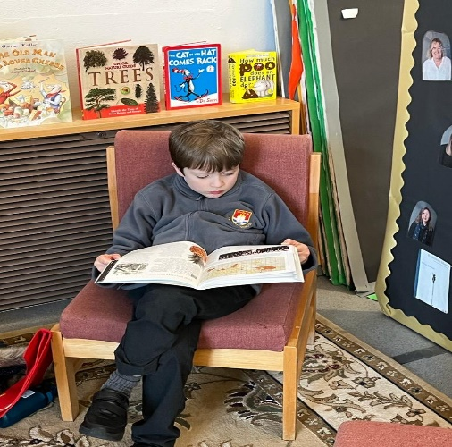
- Children are given broader reading opportunities: they are regularly invited to read during community events (eg the Remembrance service in the church) and in school performances (eg Twelfth Night in summer 2022, Nativity plays)
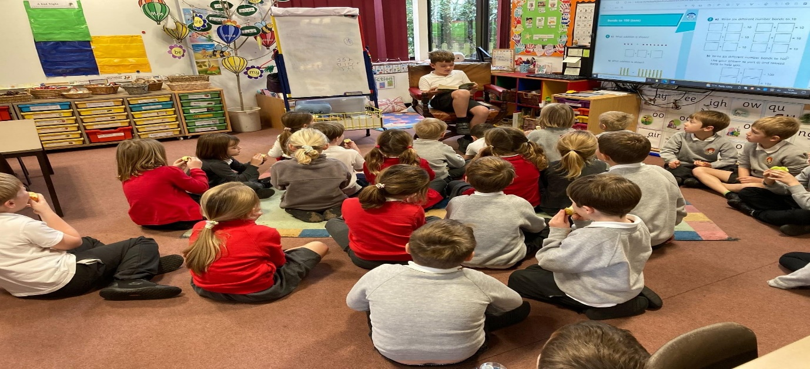
- Though staff understand the significance and importance that those timeless classics remain in our curriculum, they endeavour to remain up to date with new books published, seeking those titles which are culturally relevant to our children, while simultaneously ensuring we bring the world to our children.
How do we make sure children make progress?
- Phonics is taught daily following the Read Write Inc (RWI) progression of sounds to ensure a systematic approach.
- Phonic lessons follow the same sequence of teach, practise, revise, review and apply, including daily partner reading. Planning includes assessment for the graphemes taught. Phonics is assessed half termly to identify gaps in learning to inform future planning and intervention.
- The comprehension aspect of reading is taught through whole class guided sessions. The teachers focus their questioning on the 6 reading domains (VIPERS): vocabulary, inference, prediction, explanation, retrieval, summary and sequence.
- Children in KS2 are taught primarily using ‘Ninja’ and ‘Reading Explorers’ but other sources are employed to supplement and enrich the curriculum such as The Literacy Shed. They take part in daily ‘quick comprehension’ sessions which focus on a different are each day. They also engage in whole class ‘shared reading’ and guided reading sessions.
- Pupils who are struggling with decoding skills (preventing them from accessing reading material) have targeted interventions or are part of a smaller reading group. Targeted intervention follows the RWI scheme and staff implementing this are fully trained.
- Children are also assessed using NFER materials to further inform planning
- Pupils who need further opportunity to practise reading because they do not read at home, are given priority to read to an adult in school. Class teachers ensure volunteers, who come into school to hear readers, are trained to support reading appropriately.
- Staff hold pupil progress meetings and the Reading Lead completes pupil conferencing in reading. A focus on the lowest 20% and supportive actions is a key focus.
- We assist parents with supporting reading by providing parents meetings, reading information meetings, information on the website and letters home.
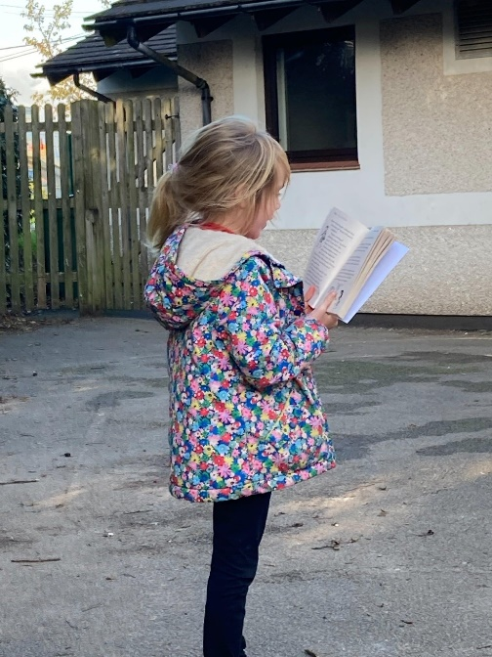

How do we match the pupil’s reading books to their phonic ability?
Through the Read Write Inc programme, children are given books that match the sounds that they have been taught. Children are then able to read with confidence and practice sounds at home.
- Pupils are assessed daily through observations in phonics, as well as half termly using the RWI assessments. Assessment then informs which books match to the pupil’s phonic ability.
- Staff in EYFS and KS1 are responsible for changing and checking the pupil’s reading books.
- Pupils who are learning phonics in EYFS and KS1 take home three books: a RWI book bag book, a Read Write Inc story book and a book for pleasure.
- Children in KS2 take home a challenge book and a reading for pleasure book. They will be assessed termly using the NFER materials as well through the more formative and ongoing reading record dialogues.

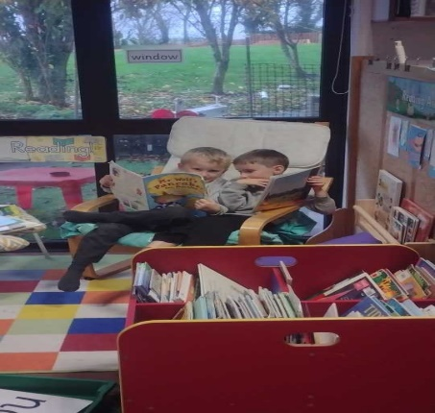
How do we teach phonics from the start?
Our children learn phonics from the day they start at school and their skills are built up in a sequence on a daily basis.
Pupils begin learning letter sounds on entry to Reception. Following the RWI system pupils are immersed in a directed teaching approach which embeds systematic phonics skills as the core skills for reading. Sounds are taught in a specific order, and regular assessment informs future planning and interventions.
First, pupils will learn to read:
- Set 1 Speed Sounds: these are sounds written with one letter: m a s d t i n p g o c k u b f e l h r j v y w z x and sounds written with two letters digraphs: sh th ch qu ng nk ck
- Words containing these sounds, by sound-blending, e.g. m–a–t mat, c–a–t cat, g–o–t got, f–i–sh fish, s–p–o–t spot, b–e–s–t best, s–p–l–a–sh splash.
Second, they will learn to read 2 or 3 sounds per week:
- Set 2 Speed Sounds: ay ee igh ow oo oo ar or air ir ou oy
- Words containing these sounds.

Third, they will learn to read:
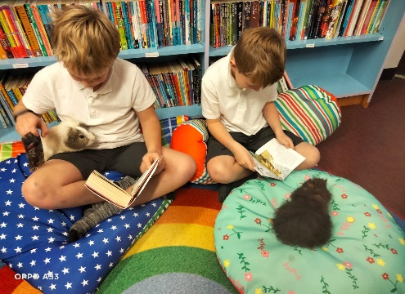
- Set 3 Speed Sounds: ea oi a-e i-e o-e
u- e aw are ur er ow ai oa ew ire ear ure
as well as the sounds ue, au, wh, ph, oe, ie
- Words containing these sounds.

How do we support children to keep up and catch up if needed?
Within the National Curriculum, it states ‘if children by the end of Year 1 are still struggling to decode and spell they need to be taught to do this urgently through a rigorous and systematic phonics programme so they catch up quickly’. Those children who are assessed as being in the lowest 20% of each year group, receive catch up interventions in the afternoons.
- Summative data is submitted once a term and pupil progress analysis is taken from this. Pupils identified by class teachers and in pupil progress meetings as not making progress have interventions planned for them and teaching staff are aware of who is a priority for intervention/support.
- Formative assessment informs day-to-day planning and teachers adapt and change this according to the pupil needs.
- Pupils who did not achieve their phonics check receive interventions (daily reader/extra phonics support).
- Where progress becomes a concern, parents are invited to a meeting with the teacher and advice is given as to how they can further support their child at home. Where necessary external agencies are employed.
- Those children in upper KS2 who are identified as falling behind will take part in the RWI catch up programme ‘Fresh Start’, and receive additional reading support with a trained adult.
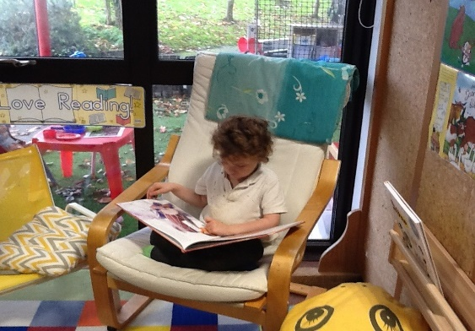
- Regular ‘Pupil Progress’ meetings are held involving the whole staff to reflect on those vulnerable children and identify appropriate strategies to ensure they meet at least expected standard.
- All children in KS2 will be assessed using NFER materials on a termly basis.

How do we train staff to be reading experts?
We have trained RWI experts. These staff attend official training at the beginning of the school year. They are regularly monitored by our school’s Reading Lead; also support visits are in place from Kernow English Hub. In addition to this, reading teachers, and specifically the Reading Lead, receive regular support from RWI mentors.
Our Reading Lead provides regular updates, training and sharing of good practice with everyone involved in the delivery of phonics and supporting early reading. These updates take place at least every half term.
All staff within our school understand the concept of RWI and within KS2 the staff have developed an effective system for whole class shared reading to build on skills that have been learned within KS1.

Reading is at the heart of everything we do!

