Abraham | Started Judaism.
Torah | Jewish Holy text.
Idol | A false god.
Ten Commandments | A set of rules to live by given to Moses by God.
Star of David | A six-pointed star adopted by Jews as a symbol of Judaism
Covenant | A binding oath or promise.
Who is God to the Jews?

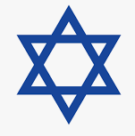
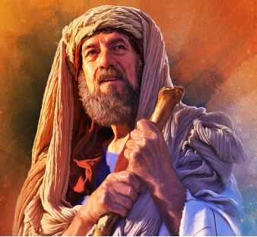

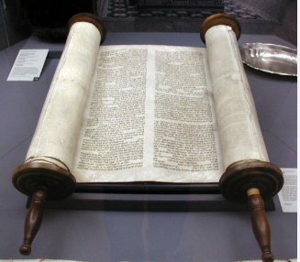
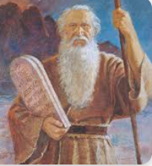

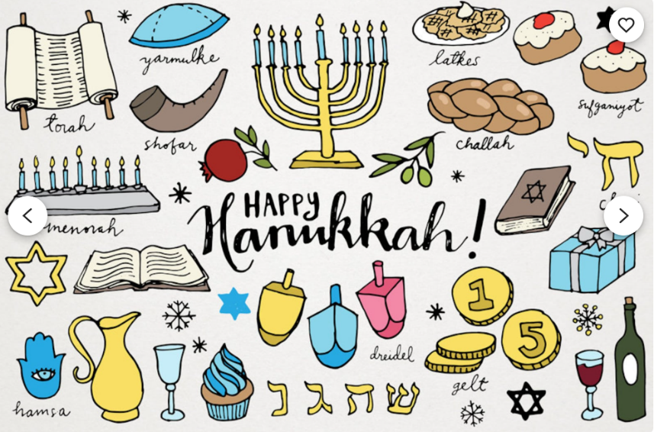
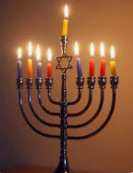
There is only one God and God created the world.
God made a special agreement with the Jewish people called ‘A
Covenant’.
God gave them a Holy Book called the Torah.
The 10 commandments are a set of rules that tells them how to live their
lives in a way that pleases God.
- These rules are found in the Torah and were given to Moses.
The Jewish day of rest, from Friday evening to Saturday evening is called Shabbat.

