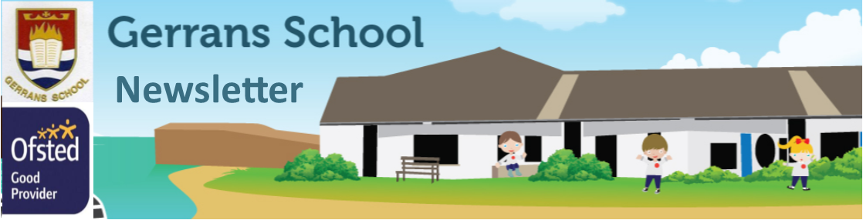

Friday 24th February

Multi Academy Trust
Our Mission, Vision and Values
Mission: The Roseland Trust provides outstanding education for our communities, where everyone succeeds.
Vision: To inspire a love of learning within environments that are happy, respectful and challenging, where everyone feels valued and able to reach their full potential.
Values: Kindness, Ambition, Responsibility.
Gerrans Very Golden Values
We are Gentle and kind
We Encourage each other
We Respect others and property
We are Resilient learners
We are Always truthful and trustworthy
We are a Nurturing environment
We are Supersonic

Respectful, Responsible and Resilient
Dear Parent(s)/Carer(s),

Welcome back from half-term! I hope that you enjoyed the lovely weather with your families. Welcome to the first of our weekly newsletters, I hope this proves useful in sharing important information and keeping you up-to-date with what has been happening in school each week.

Despite some concerns, pupils have settled well into the new morning routines and pupils are calm and ready to learn at the start of the school day. If you have any questions regarding this, please email me head@tregony.cornwall.sch.uk

Next Thursday, the school will be celebrating World Book Day, everyone should have received an email regarding this.

Staffing - Porthcurnick Class

Sadly Mrs Brammer is leaving Gerrans we will all be very sorry to see her go but she has a new, permanent position. Mrs Brammer’s last day will be Tuesday 28th February. With this in mind, from Friday 3rd March Mr Steward will be teaching every Friday along with his usual Wednesday and Thursday and Mrs Michelle Brown will be teaching every Monday and Tuesday starting on Monday 6th March.

St Pirans Day

On Friday 3rd March we will be having a special St Piran’s Day menu of Traditional Cornish Steak Pasty or a Cheese and Onion Pasty both with chips and beans followed by a Scone with Jam and Cream
( jam first!).

School Payments

Thank you to everyone who is now using the School Gateway, please ensure you regularly access your accounts to keep payments up-to-date. The Gateway is open for our Key Stage 2 camp payment which is by Thursday 16th March. Don’t forget you can pay in smaller instalments rather than the whole amount in one go. We will no longer be sending weekly dinner money reminders, please check your account for your dinner balances. Thank you.

Towan Class

Our new topic this half term is ‘Around the World in 20 Days’. Please check book bags for information about the Show and Tell home learning project, due on Monday 20th March.

This week we were spell-bound with the wonderfully rich vocabulary in Ruby’s book choice: The Lost Bear, by Hannah Gold. Thank you Ruby!

We began learning about three different countries in Geography, and have started to get to grips with fractions, multiplication and addition.

Porthcurnick Class

In maths Y4 have begun a fractions unit of learning, Y5 are concentrating on decimals and percentages and Y6 are learning about decimals.

In reading comprehension Y3 and Y4 are reading from The Little Match Girl and Y5 and Y6 are reading from The Hound of the Baskervilles.

In spelling Y3 and Y4 are concentrating on adding suffixes to words. Y5 and Y6 are looking at words containing silent letters.

In writing we are writing descriptions and newspaper reports.

Our new topic is Fever, Fire and Fashion which is a history topic relating to 17th century London, the plague and the fire of London.

Y6 are starting to prepare for their SATS tests in May and practice workbooks will be going home shortly.

Tatams Class

Tatams Class have had a super week, enjoying our newly improved outside area. We have started to explore our new topic - “How do things move?”. We have diggers in the kinetic sand, a soapy car wash outside and have been painting different vehicles. The children have enjoyed joining in with retelling the Marmalade Jam story.

The children have also enjoyed using the lovely wooden food and utensils in your home corner, kindly donated by Alfie’s family. Thank you also to Coral’s family for the generous donation of two medical and a dentist role play sets. There has been some wonderful conversation and collaboration whilst using them.

We would really appreciate any donations of small boxes and kitchen roll tubes etc for junk modelling, (nothing bigger than a cereal box please as the bigger the boxes, the bigger the creations that come home!) Thank you.

Kate Douglass

Acting Headteacher
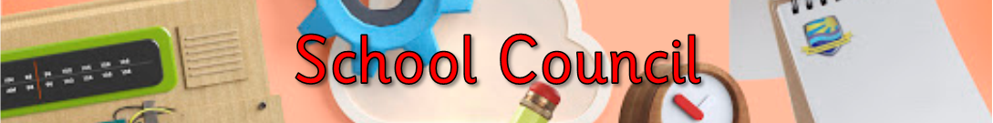

Tatams - River  Towan ~ Harris  Porthcurnick ~ Brooke | Yellow: 125  Green: 117  Blue: 52  Red: 120
- School Gateway - All  - World Book Day - All  - SATs Information Meeting - Year 6 | Tatams: 95.1%  Towan: 94.6%  Porthcurnick: 94.07%
Please see the link below for our latest online safety newsletter and up-to-date guidance on how to stay safe online.

https://www.nspcc.org.uk/keeping-children-safe/online-safety/

https://newzapp-files.s3.eu-west-2.amazonaws.com/customers/18375/documents/OLSNewsletterparentsDec2022002-81e5b7ab.pdfs/18375
/documents/OLSNewsletterparentsDec2022002-81e5b7ab.pdf

Thursday 2nd March: World Book Day
Friday 3rd March: St Piran’s Day school dinner menu
Inset Days for 2022/23
- Friday 9th June 2023
- Monday 24th July
- Tuesday 25th July
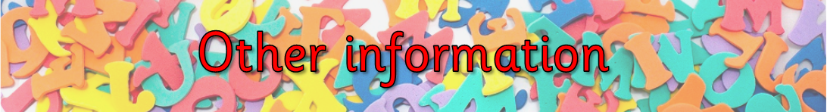

Thank you to everyone who took part in our “Wear Red” day in aid of Cornwall Air Ambulance. We raised £54.

