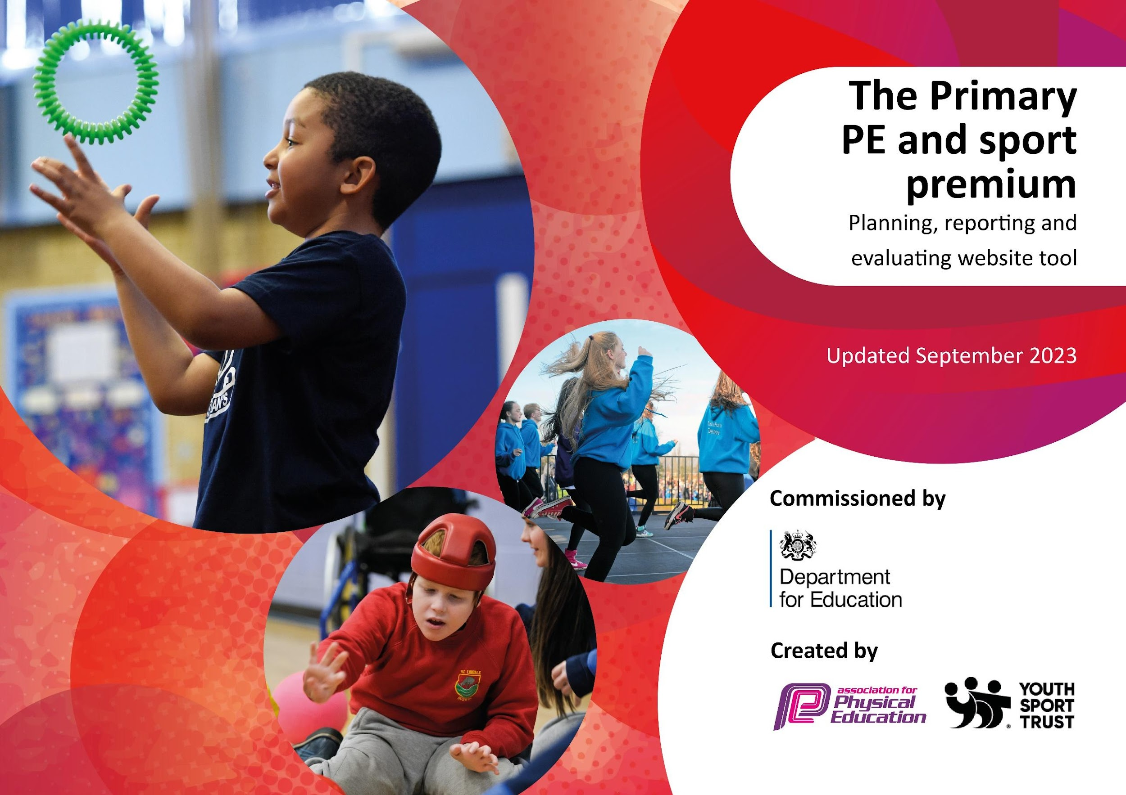

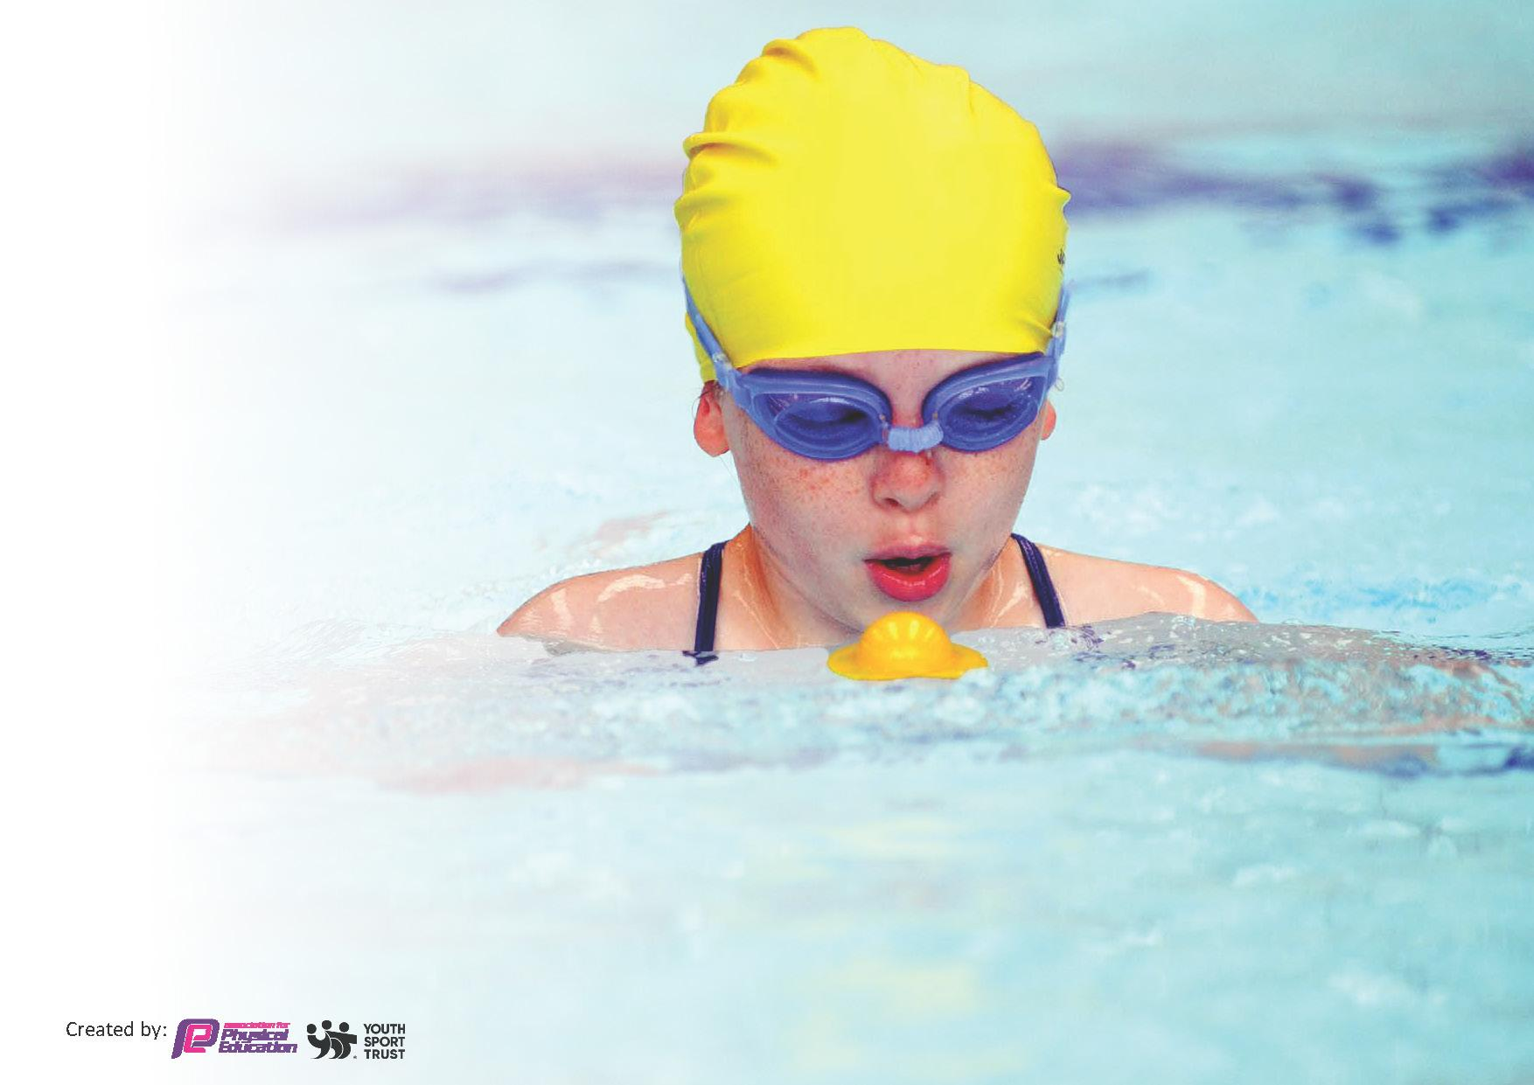
This template can be used for multiple purposes:
by:
- It enables schools to effectively plan their use of the Primary PE and sport premium
- It helps schools to meet the requirements (as set out in guidance) to publish information on their Primary PE and sport premium
- It will be an effective document to support Ofsted inspections enabling schools to evidence progress in Physical Education (PE) and evidence swimming attainment, which forms part of the PE National Curriculum. We would recommend schools consider
the Intent, Implementation and Impact of any spend, as examined within the Education Inspection Framework.

It is important that your grant is used effectively and based on school need.

Schools must use the funding to make additional and sustainable
improvements to the quality of the PE, School Sport and Physical Activity (PESSPA)
they offer. This means that you should use the Primary PE and sport premium to:

- Build capacity and capability within the school to ensure that improvements made now will benefit pupils joining the school in future years
- Develop or add to the PESSPA activities that your school already offers.

The Primary PE and sport premium should not be used to fund capital spend projects; the school’s core budget should fund these. Further detail on capital expenditure can be found in the updated Primary PE and sport premium guidance.

The Primary PE and sport premium guidance, outlines 5 key priorities that funding should be used towards. It is not
necessary that spending has to meet all the key priorities, you should select the priorities that you aim to use any funding towards.

Although completing this template is not a requirement for schools, schools are required to publish details of how they spend this funding. Schools must also outline what the impact this funding has had on pupils’ PE and sport participation and attainment and how any spending will be sustainable in the future. All funding must be spent by 31st July 2024.

The Department for Education has worked closely with the Association for Physical Education (afPE) and the Youth Sport Trust (YST) to develop this template and encourages schools to use it. This template is an effective way of meeting the reporting requirements of the Primary PE and sport premium.
Review of last year’s spend and key achievements (2022/2023)

Activity/Action | Impact | Comments
The Roseland School Sports Network and membership to the TRLC | To organise and run sporting events within our cluster. These then lead on to the second level with MCSN. These sporting events also include ones that are targeted at those less active and also engages Pupil Premium pupils which ensures more and/or reluctant pupils are involved in sporting activities.  Pupils across KS2 have taken part in various cluster competitions as well as cross country for Mid Cornwall, netball and multi sports. This results in high involvement across KS2 in sport.  TRLC competitions aimed at different groups of pupils to increase opportunity, improve resilience, self-esteem, teamwork and well-being. | It is the school’s aim that all pupils take part in some competitive sports by the time they leave the school.  Staff have received mini-bus training so that we can support pupils’ involvement in these events as transportation costs were a significant barrier to attend these events. This investment will have a long-term impact.
Equipment | To ensure that we have a wide range of sports kit and resources that will aid us in offering a variety of sports during lessons, in clubs and during break times. The curriculum can be confidently taught with the correct resources. | An inventory was taken to find out  which equipment needed to be replaced and to identify shortfalls needed to facilitate our new curriculum. Items were purchased.  We ensure that staff always have what is needed for lessons and our outside club providers also make use of our equipment. The School Council regularly makes suggestions of equipment that is needed particularly to encourage activity at playtimes.
Transport, supervision and CPD of swimming and other sporting activities. | To ensure that all pupils across Key Stage 2 have an opportunity to engage in sporting events and swimming.  To ensure that specialist swimming instructors teach pupils to swim whilst upskilling teachers in this process  All Year 6 pupils apart from one met the national swimming requirements. | All Key Stage 2 pupils are taught to swim with the correct technique. Those Year 6 pupils that can swim more than 25 metres are also taught how to self-life save  All pupils are taught to swim with the correct technique. Those Year 6 pupils that can swim more than 25 metres are also taught water life saving techniques.  Staff have received mini-bus training so that we can support pupils’ involvement in these events as transportation costs were a significant barrier to attend these events. This investment will have a long-term impact.
Sporting events and activities throughout the year.  Subsidised Active Camps | Year 6 take part in sailing yearly which involves all pupils. This has led to some pupils taking up sailing outside of school, as well as some gifted and talented pupils being supported to compete in sailing regattas.  Paddle lessons provide pupils with the opportunity to try a new sport and each year we see an increase in confidence from pupils due to them trying something outside of their comfort zone.  Active, sports focussed camps are chosen where pupils have the opportunity to take part in land and sea sports, including outdoor learning such as making fires,orienteering, tree planting etc.  Bikeability cycle training equips children with vital life skills. Pupils not only learn to cycle, they gain independence, social skills and a sense of wellbeing. After Bikeability, children are better at responding to risk. As a result, more children cycle to school which in turn improves mental health and wellbeing. This allows children to get more out of the classroom, improving their attention span and engagement. Healthier habits lead to increased attendance and improved academic results  Pupils have the opportunity to play squash with specialized coaches, using the facilities within the community.
Updating PE equipment and resources. | More pupils meeting their daily physical activity goal, more pupils encouraged to take part in sporting activities.  Teachers have the resources needed to carry out effective teaching

Key priorities and Planning

Total Funding Received Year 2023-2024 | £16,490

Action – what are you planning to do | Who does this action impact? | Key indicator to meet | Impacts and how sustainability will be achieved? | Cost linked to the action
Sport and physical activity opportunities on the playground to allow pupils to engage with more physical activity, every day.  To purchase new equipment in order to offer a variety of physical activities during both PE and break times.  Support staff time, CPD and resources in order to run fun-fit sessions to children with SEN and TIS needs and promote engagement in regular physical activity. | Lunchtime supervisors / teaching staff, coaches - as they need to lead the activities  Sports Leaders to raise the profile of sport and physical activity by promoting physically active playtimes as well as helping improve playground behaviour and encourage the development of team work  Pupils – as they will take part. | Key indicator 2 -The engagement of all pupils in regular physical activity – the Chief Medical Officer guidelines recommend that all children and young people aged 5 to 18 engage in at least 60 minutes of physical activity per day, of which 30 minutes should be in school.  Key Indicator 3: The profile of PE and sport is raised across the school as a tool for whole school improvement. | More pupils meeting their daily physical activity goal, more pupils encouraged to take part in sporting activities.  Improved behavior on the playground.  Staff are upskilled in encouraging physical activity. | £10,000 costs for additional CPD to support lunchtime sessions and new outside space for Early years and Key Stage 1

Swimming CPD for teachers and swimming lessons for all EYFS and Key Stage 1 pupils.  To purchase a PE curriculum that provides teachers with specialist plans that will support them with the appropriate skills and knowledge | Primary generalist teachers.  Pupils | Key Indicator 1: Increased confidence, knowledge, and skills of all staff in teaching PE and sport. | Primary teachers more confident to deliver effective swimming supporting pupils to undertake extra activities inside and outside of school, including teaching water safety and swimming and as a result improved pupil’s attainment in PE.  To lower the reliance on coaches from outside agencies.  To lower the reliance on coaches from outside agencies by buying into and implementing, an evidence backed, scheme of work. Specialist member of staff to run CPD sessions to secure implementation of this | £2000 for 5 teachers to undertake CPD alongside swimming lessons and the additional staffing and transport costs.  £1000 curriculum  To implement, and embed, a PE scheme of work throughout school and actively promote this change throughout school.
To take part in interschool sporting events run through the partnership with The Roseland Cluster to promote PE across the school in conjunction with the cluster sports lead  To partake in sporting fixtures with local schools to initiate a team/community feel to current school culture.  To attend as many cluster, and TRLC sporting events as possible, giving all children equal opportunities not entirely based on ability | Pupils | Key indicator 5: Increased participation in competitive sport | Upskilling of staff from specialist coach  Transport costs are a huge barrier due to our geographical location. Investing in staff training will facilitate pupils attendance at sporting events and activities | Employment of cluster schools coach  £1000  Additional staffing and mini-bus costs  £1000  Further staff mini-bus training (and cover costs)  £1000  To continue to deliver different sporting and physical activity opportunities during camp week.
To provide pupils with wider sporting activity opportunities  To ensure there are wide and varied opportunities to engage in a wide range of extracurricular activities  To run bikeability for children in years 5 and 6 to promote cycling as a means of being active  To run sailing lessons for Year 6 pupils  To run a key stage 2 surf school  Staff to teach alongside specialist coaches (employ specialist coaches in a range of other sports)  To employ specialist coaches to lead a variety of extracurricular sports clubs to give children access to a range of different sporting activities in order to promote life-long participation for all. | Pupils  Staff | Key indicator 4: Broader experience of a range of sports and activities offered to all pupils. |  | Sailing  £1500  Bikeability costs and staffing  £500  To promote a variety of outside of school sports opportunities when communicating with parents/guardians and children. 5. To make greater links with a wider range of local sports clubs.

Signed off by:

Head Teacher: | Kate Douglass
Subject Leader or the individual responsible for the Primary PE and sport premium: | Kayleigh Mulroy/Julie Elvy
Date: | December 2024

Key achievements 2023-2024

This template will be completed at the end of the academic year and will showcase the key achievements schools have made with their Primary PE and sport premium spending.

Activity/Action | Impact | Comments
Membership to The Roseland School Sports Network and membership to the TRLC; including specialist teaching. | Upskilling of staff from specialist coach  Transport costs are a huge barrier due to our geographical location. Investing in staff training will facilitate pupils attendance at sporting events and activities | All year 6 pupils have had the opportunity to take part in inter school competition throughout the year and various sports.  Competition has been inclusive, with pupils of all abilities taking part. Younger pupils have also had sporting opportunities.
Sport and physical activity opportunities on the playground to allow pupils to engage with more physical activity, every day.  To purchase new equipment in order to offer a variety of physical activities during both PE and break times.  Support staff time, CPD and resources in order to run fun-fit sessions to children with SEN and TIS needs and promote engagement in regular physical activity. | More pupils meeting their daily physical activity goal, more pupils encouraged to take part in sporting activities.  Improved behavior on the playground.  Staff are upskilled in encouraging physical activity | Pupils are enjoying the different active areas on the playground, encouraging them to stay active throughout break times.  Year 6 playground leaders encourage pupils to take part in activities and help to ensure that they are involved and behaving (alongside staff).  Behaviour has improved as a result of increased provisions.
Swimming CPD for teachers and swimming lessons for all EYFS and Key Stage 1 pupils.  To purchase a PE curriculum that provides teachers with specialist plans that will support them with the appropriate skills and knowledge | Primary teachers are more confident to deliver effective swimming. supporting pupils to undertake extra activities inside and outside of school, including teaching water safety and swimming and as a result improved pupil’s attainment in PE.  To lower the reliance on coaches from outside agencies.  To lower the reliance on coaches from outside agencies by buying into and implementing, an evidence backed, scheme of work. Specialist member of staff to run CPD sessions to secure implementation of this | Pupils enjoy their swimming lessons and parents appreciate them being taken throughout the school, an important skill to learn with living by the sea.  Teachers take part in CPD through observing specialists, providing them with ideas and aiding their confidence with teaching the subject. Also, ensuring that pupils enjoy lessons and have a positive attitude towards sport, no matter their ability.  Despite it not being an expectation all pupils  EYFS and Key Stage 1 benefit from swimming lessons.This is considered of the highest importance due to our geographical location.  88% of pupils at the end of Key Stage 2 could swim 25 meters on their back and front.
To provide pupils with wider sporting activity opportunities  Surfing, bikeability, different club activities – dodgeball, archery, nerf, street surfing | Broader experience of a range of sports and activities offered to all pupils. | KS2 have taken part in surf days as well as different water based sports during their camps.  Year 6 pupils completed bikeability, with a high L2 pass rate.  By bringing in coaches to run clubs, pupils have been able to take part in different sporting activities, instead of the mainstream ones.

