RWI phonics – The Teaching of Early Reading at Gerrans
At Gerrans, we strive to teach children to read effectively and quickly using the Read Write Inc. Phonics programme (RWI) which includes teaching synthetic phonics, sight vocabulary, decoding and encoding words as well as spelling and accurate letter formation.
We passionately believe that teaching children to read and write independently, as quickly as possible, is one of the core purposes of a primary school. These fundamental skills not only hold the keys to the rest of the curriculum but also have a huge impact on children’s self-esteem and future life chances. Using the RWI phonics program we teach children to:
- read easily, fluently and with good understanding
- develop the habit of reading widely and often, for both pleasure and information
- write clearly, accurately and coherently, adapting their language and style in and for a range of contexts, purposes and audiences
In practice, children learn the 44 common sounds in the English language and are taught how to blend these sounds to decode (read) words. We start by teaching children to read and blend the first thirty Set 1 sounds. Once they have conquered this skill, they start reading stories and texts that have words made up of the sounds they know. This means that they can embed and apply their phonic knowledge and start to build their reading fluency. Once secure, children learn Set 2 and Set 3 sounds and then read texts with increasingly more complex sounds and graphemes. Throughout this process there is a focus on comprehension, reading with expression and reading for enjoyment.
Children are taught in small groups which reflect their phonic knowledge and reading fluency. We regularly assess children (half termly) so that they are taught in a RWI group which matches their phonic knowledge as closely as possible. We make sure that pupils read books that are carefully matched to their increasing knowledge of phonics and ability to read those ‘tricky words’ (red words), so they experience early reading success and thus gain confidence in and identify themselves as readers.

The Importance of Reading
Children who read regularly, or are read to, have the opportunity to open doors to so many different worlds! More importantly, reading will give your child the tools they need to become independent life-long learners. We can achieve this together through
- Using the Read Write Inc program to help your child to read at school
- Encouraging children to develop a love of books and fluency by reading daily at home and at school
- Giving children access to a wide range of books at school and at home
What is Read Write Inc?
Read Write Inc (RWI) is a complete phonics/literacy programme which helps all children learn to read fluently and at speed, so they can focus on developing their skills in comprehension, vocabulary and spelling. The programme is designed for children ages 4-7. However, at Tregony, we begin to expose children in our nursery to skills that will help them access the taught programme in Reception. If needed, we continue teaching RWI to children beyond the age of 7, as we use a stage, not age approach. RWI was developed by Ruth Miskin and more information on this can be found at
https://www.ruthmiskin.com/parents/

How will my child be taught to read?
We start by teaching phonics to the children in Reception Class. This means that they learn how to 'read' the sounds in words and how those sounds can be written down. This is essential for reading, but it also helps children learn to spell well. We teach the children simple ways of remembering these sounds and letters.

Reading
The children:
- Learn 44 sounds and the corresponding letters/letter groups using simple picture prompts - see below
- Learn to read words using 'Fred Talk' (see below) and sound blending
- Read from a range of storybooks and non-fiction books matched to their phonics knowledge
- Work well with partners
- Develop comprehension skills in reading by answering 'find it' and 'prove it' discussion questions

Writing
The children:
- Learn to write and form letters/letter groups correctly, which represent the 44 sounds with the help of fun phrases
- Learn to write words using 'Fred Talk'
- Learn to build sentences by practising sentences out loud before they write them
Talking
The children work in pairs so that they:
- Answer every question
- Practise every activity with their partner
- Take turns in talking and reading to each other
- Develop ambitious vocabulary
Progressing through stages
Children in Year 1 and 2 follow the same format as Reception, but will work on complex sounds and read books appropriate to their reading level. Daily sessions of RWI phonics initially last 30 minutes, progressing to hour long sessions by the end of the reception year. Once children become fluent speedy readers, they will move on to the RWI spelling programme.

Five key principles that underpin the teaching in all Read Write Inc. sessions:
Purpose- know the purpose of every activity and share it with the children, so they know the one thing they should be thinking about
Participation- ensure every child participates throughout the lesson. Partnership work is fundamental to learning
Praise- ensure children are praised for effort and learning, not ability
Pace- teach at an effective pace and devote every moment to teaching and learning
Passion-be passionate about teaching so children can be engaged emotionally

Children will be taught how to read as follows:
Before you start to teach your child, practise saying the sounds below. These are the sounds we use to speak English. Children initially begin using picture for each sounds; this will help them recognise the sound and then form the shape of the sound.

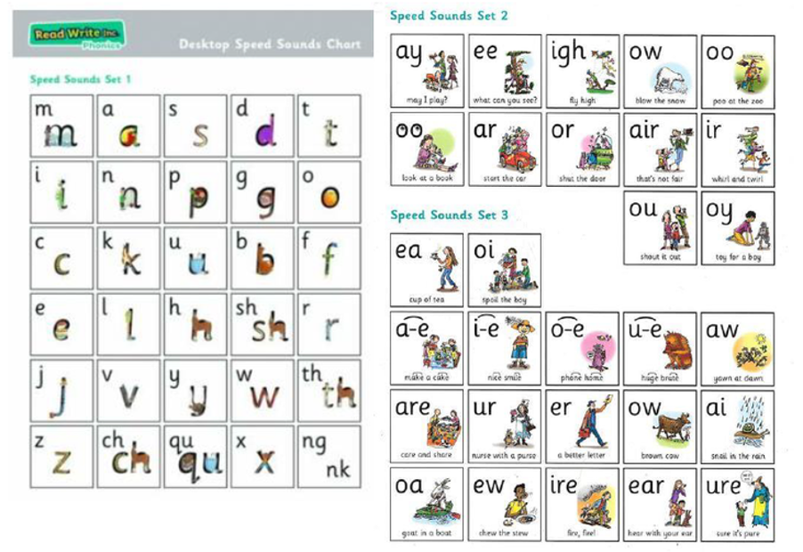

Fred Talk
We use pure sounds ('m' not 'muh', 's' not 'suh' etc, otherwise known as ‘schwaring’!) so that your child will be able to blend the sounds into words more easily. In RWI lessons, we use a puppet called Fred, who is an expert in sounding out words! We call it 'Fred Talk' e.g. m-o-p, c-a-t, m-a-n, sh-o-p, b-l-a-ck.

Reading Sessions:
Within all the RWI book sessions, children will be exposed to red and green words to learn to help them to become speedy readers. Red words are words that are not easily decodable and challenge words to extend children's vocabulary. Green words are linked to the sound they have been learning and are easily decodable.

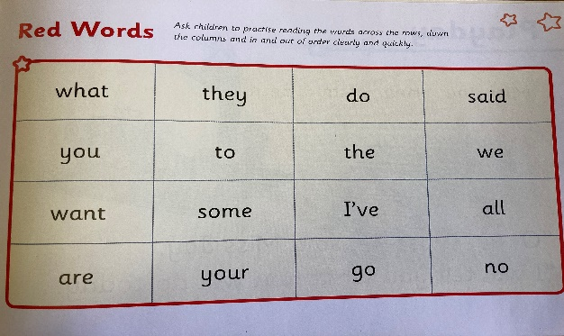
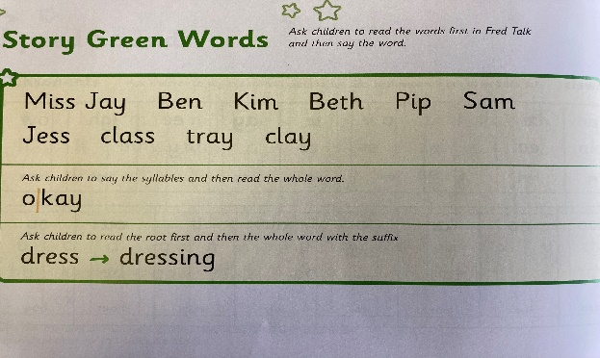

Dots and dashes represent the sound each letter makes. Dots represent a single letter sound, and dashes represent sounds which have 2 or more letters. These types of sounds are called 'special friends'. Children are encouraged to spot if there are any special friends in a word, before reading it. During the RWI session, children will read the book three times and, at each new reading, they will have plenty of opportunities to practise using their developing comprehension skills.

What are the sounds taught?

Set 1 speed sounds: these are sounds represented by a single letter -

m a s d t I n p g o c k u b f e l h r j v w z x

and sounds with two letters (digraphs) – sh th ch qu ng nk ck

Set 2 speed sounds:

ay ee igh ow oo (as in zoo) oo (as in look) ar or air ir ou oy

Set 3 speed sounds:

ea oi a-e i-e o-e u-e aw are (as in share) ur er ow ai oa ew ire ear ure ue au ph wh oe ie

Writing Sessions:
You may have heard your child talking about 'Hold, edit or build a sentence.'
Hold a sentence is an activity that encourages children to remember a whole sentence while focusing on spelling and punctuation.
Build a sentence gives children the opportunity to create their own sentences to that shows the meaning of a word and edit a sentence allows the children to critique a sentence using their knowledge of spelling, punctuation and grammar. Children complete a longer piece of independent writing, which gives them the opportunity to show off their creativity and to practise their spelling, grammar and punctuation.
Proof reading
Children learn the importance of checking and proof reading their writing in order to spot and correct any mistakes they may have made. This important skill is taught from the start of the Green Get Writing book, and requires children to find and correct errors that have been made in a short sentence.

How you can help at home

- Read to your child and always discuss the story you are reading to try to build your child’s comprehension skills, inference and understanding.

- Practise the sounds they know at home. These are the sounds in the Speed Sound Chart at the start of the storybooks.

- Listen to your child read; both their RWI book-bag books and other books, every day. Make sure that your child brings their RWI books into school every day.

- Talk to them! The most important thing you can do is to talk to your child and listen to them when they are talking to you. Try to extend their vocabulary range and their skill at talking in increasingly more complex sentences. For example, try to teach them alternative words for ideas, or nouns they already know.

- Look out for our RWI Workshops, where you can find out about how we teach phonics at here at Gerrans, so that you are best placed to support your child’s reading journey

- Make sure that your child attends school every day, and that they are on time, as this will help your child to be ready to learn and make the most progress.

Useful websites for Parents
Please find a list of websites that you may find useful in helping you and your child learn about phonics. Games and fun activity websites are also included.
https://www.ruthmiskin.com/en/find-out-more/parents/ - Information and resources to support phonics learning at home
http://www.bbc.co.uk/bitesize/ks1/literacy/phonics/play/ - fun games for the children to play
http://www.ictgames.com/literacy.html - fun games for the children to play
http://www.firstschoolyears.com/ - fun games for the children to play
BBC Bitesize - many games to play covering all areas of the curriculum

If you need further advice or help with how best to help, please contact the RWI Lead teacher (Emily Haines) who will be happy to meet with you.

