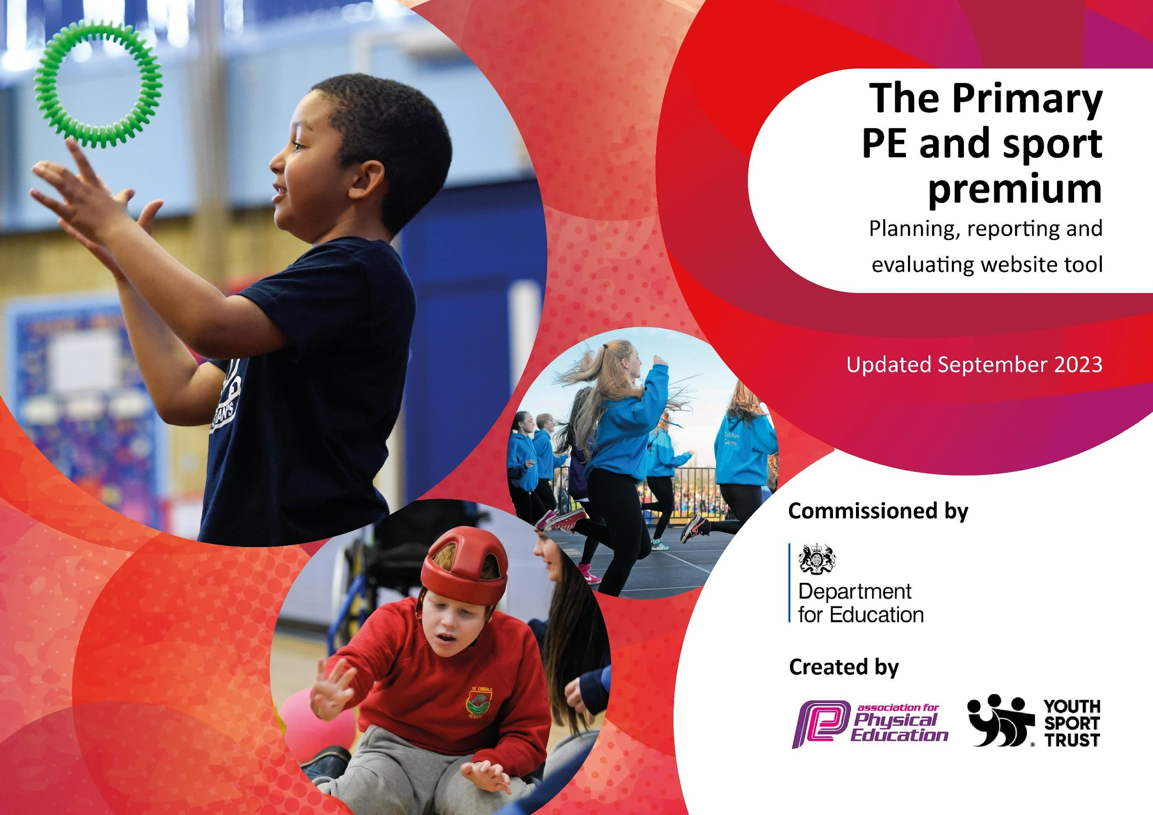

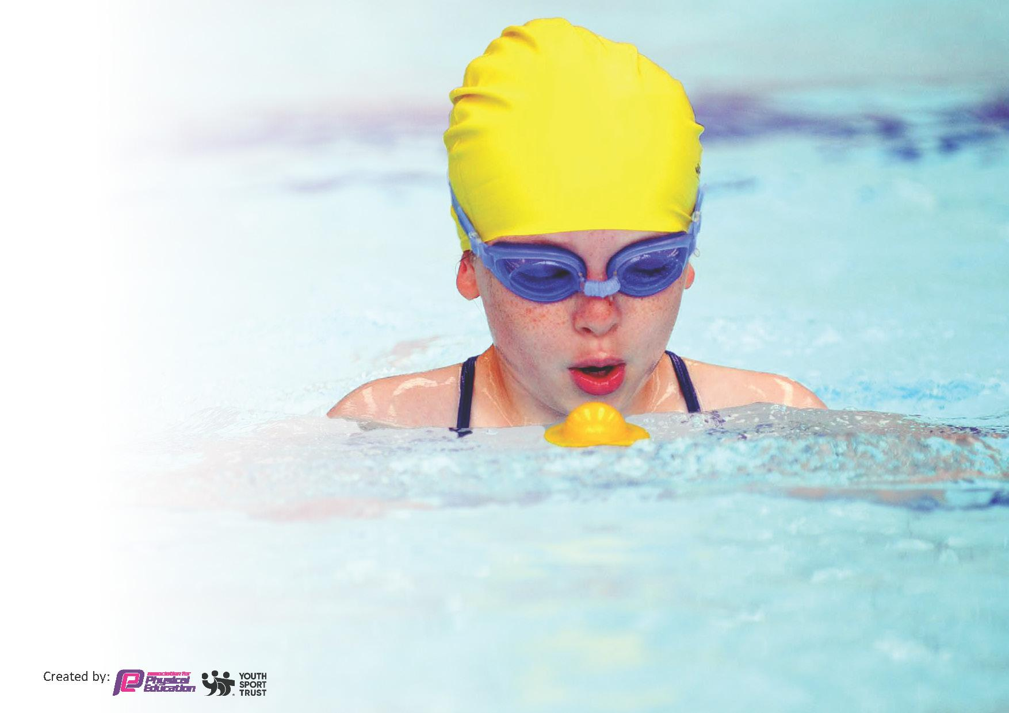
This template can be used for multiple purposes:
by:
- It enables schools to effectively plan their use of the Primary PE and sport premium
- It helps schools to meet the requirements (as set out in guidance) to publish information on their Primary PE and sport premium
- It will be an effective document to support Ofsted inspections enabling schools to evidence progress in Physical Education (PE) and evidence swimming attainment, which forms part of the PE National Curriculum. We would recommend schools consider
the Intent, Implementation and Impact of any spend, as examined within the Education Inspection Framework.

It is important that your grant is used effectively and based on school need.

Schools must use the funding to make additional and sustainable
improvements to the quality of the PE, School Sport and Physical Activity (PESSPA)
they offer. This means that you should use the Primary PE and sport premium to:

- Build capacity and capability within the school to ensure that improvements made now will benefit pupils joining the school in future years
- Develop or add to the PESSPA activities that your school already offers.

The Primary PE and sport premium should not be used to fund capital spend projects; the school’s core budget should fund these. Further detail on capital expenditure can be found in the updated Primary PE and sport premium guidance.

The Primary PE and sport premium guidance, outlines 5 key priorities that funding should be used towards. It is not necessary that spending has to meet all the key priorities, you should select the priorities that you aim to use any funding towards.

Although completing this template is not a requirement for schools, schools are required to publish details of how they spend this funding. Schools must also outline what the impact this funding has had on pupils’ PE and sport participation and attainment and how any spending will be sustainable in the future. All funding must be spent by 31st July 2025.

The Department for Education has worked closely with the Association for Physical Education (afPE) and the Youth Sport Trust (YST) to develop this template and encourages schools to use it. This template is an effective way of meeting the reporting requirements of the Primary PE and sport premium.
Review of last year’s spend and key achievements (2024/2025)

Activity/Action | Impact | Comments
Promote daily physical activity by providing playground equipment, active play opportunities, Fun Fit sessions for SEND and TIS pupils, and developing Sports Leaders to encourage active playtimes. | Pupils have increased their participation in daily physical activity through structured playground activities, improved equipment and inclusive intervention sessions. Sports Leaders have successfully encouraged active play, teamwork and positive behaviour during lunchtimes, while staff have developed greater confidence in leading physical activity. | Investment in playground equipment has created more opportunities for active play throughout the school day. Staff CPD has supported the delivery of inclusive Fun Fit sessions, ensuring SEND and TIS pupils are fully engaged. Sports Leaders continue to promote physical activity and positive behaviour, embedding an active culture across the school.
Implement and embed a progressive PE curriculum, including swimming CPD, specialist curriculum resources and staff training to improve teaching across the school. | Staff confidence, subject knowledge and consistency in delivering high-quality PE have improved. Pupils have benefited from a progressive curriculum, resulting in improved skill development, increased confidence and higher levels of engagement in PE. Swimming provision has enhanced pupils' water confidence and safety awareness. | Teachers have accessed high-quality CPD and implemented a consistent scheme of work across the school. Reduced reliance on external coaches has strengthened staff expertise and ensured sustainable improvements to PE provision. Curriculum resources will continue to support high-quality teaching in future years.
Provide opportunities for pupils to participate in inter-school competitions and festivals through the Roseland Cluster and local sporting partnerships. | Participation in competitive sport has increased, providing pupils with opportunities to develop resilience, teamwork, leadership and sportsmanship. A greater number of pupils have represented the school through inclusive selection opportunities. | Strong partnerships with the Roseland Cluster and local schools have enabled regular participation in competitions despite geographical challenges. Investment in transport, minibus training and staffing has ensured pupils continue to access a wide range of sporting events.
Broaden pupils' sporting experiences through activities including Camp Week, sailing, surfing, Bikeability, extracurricular clubs and links with local sports clubs. | Pupils have accessed a wider range of sports and outdoor activities, increasing confidence, enjoyment and participation in physical activity. Many pupils have experienced activities they would not otherwise have had the opportunity to try, encouraging lifelong engagement in healthy lifestyles. | Specialist coaches have worked alongside staff to build confidence and expertise while providing high-quality experiences for pupils. Stronger links with local sports clubs have supported continued participation beyond school and promoted lifelong physical activity.

Key priorities and Planning

Total Funding Received Year 2025-2026 | £16,580

Action – what are you planning to do | Who does this action impact? | Key indicator to meet | Impacts and how sustainability will be achieved? | Cost linked to the action
Implement and embed a progressive PE curriculum across all year groups, ensuring clear progression of skills and knowledge. Provide staff training, mentoring and curriculum resources to develop staff confidence and improve the quality of PE teaching. | All pupils and teaching staff. | Key Indicator 1: Increased confidence, knowledge and skills of all staff in teaching PE and sport. | Staff confidence and subject knowledge will continue to improve through targeted CPD, mentoring and high-quality curriculum resources. A progressive curriculum will ensure consistent PE provision and reduce the need for future external support. | £4,600
Provide opportunities for all pupils to participate in inter-school festivals and competitions through the Roseland Cluster and School Games partnership, ensuring opportunities are available to pupils of all abilities. | All pupils, particularly those who may not usually represent the school in sport. | Key Indicator 5: Increased participation in competitive sport. | Pupils will benefit from regular participation in festivals and competitions, developing confidence, teamwork and resilience while strengthening links with local schools. Continued partnership working will ensure sustainable access to a varied competition calendar. | £2,600
Broaden pupils' sporting experiences by providing alternative activities such as surfing, sailing, Bikeability and additional swimming opportunities, with a focus on supporting SEND pupils and those less engaged in traditional sports. | SEND pupils, less active pupils and all children through enrichment opportunities. | Key Indicator 4: Broader experience of a range of sports and physical activities offered to all pupils. | Pupils will experience activities they may not otherwise access, improving confidence, participation and physical literacy. Strong partnerships with external providers will enable these opportunities to continue and encourage lifelong participation in physical activity. | £3,200
 | Pupils across all year groups. | Key Indicator 2: Engagement of all pupils in regular physical activity. | A varied extra-curricular programme will increase participation in physical activity, improve health and wellbeing, and provide pathways into competitive sport. Investment in equipment and staff-led clubs will ensure the programme remains sustainable year after year. | £4,680
  Provide a range of extra-curricular sporting activities through teacher-led clubs, including football, netball, athletics and seasonal activities, supported by appropriate equipment and resources. |  | Key Indicator 2: Engagement of all pupils in regular physical activity. | A varied extra-curricular programme will increase participation in physical activity, improve health and wellbeing, and provide pathways into competitive sport. Investment in equipment and staff-led clubs will ensure the programme remains sustainable year after year.
Raise the profile of PE and physical activity across the school by promoting active playtimes, whole-school participation events and healthy lifestyles. This includes providing playground equipment, organising a whole-school Mini Marathon and promoting healthy morning snacks. | All pupils and staff. | Key Indicator 3: The profile of PE and sport is raised across the school as a tool for whole-school improvement. | Improved playground resources will encourage active play during break and lunchtimes. Whole-school events such as the Mini Marathon will promote inclusion and physical activity, while healthy snack initiatives will reinforce healthy lifestyle choices. These initiatives will become embedded within the school culture and continue to benefit future cohorts. | £1,500

Swimming Assessments (2025-26)

Meeting National Curriculum requirements for swimming and water safety.
Priority should always be given to ensuring that pupils can perform safe self-rescue even if they do not fully meet the first two requirements of the National Curriculum programme of study

Question | Stats: | Further context  Relative to local challenges
What percentage of your current Year 6 cohort can swim competently, confidently and proficiently over a distance of at least 25 metres? | 100% | All KS2 have taken part in swimming. They swim for five consecutive afternoons in a week and pupils were taught by a specialist swimming instructor. The impact of this is significant as pupils’ progress quicker.
What percentage of your current Year 6 cohort can use a range of strokes effectively [for example, front crawl, backstroke, and breaststroke]? | 100%
What percentage of your current Year 6 cohort are able to perform safe self-rescue in different water-based situations? | 100%
If your schools swimming data is below national expectation, you can choose to use the Primary PE and sport premium to provide additional top-up sessions for those pupils that did not meet National Curriculum  requirements after the completion of core lessons. Have you done this? | Yes/No
Have you provided CPD to improve the knowledge and confidence of staff to be able to teach swimming and water safety? | Yes/No | The school has paid for qualified instructors at the pool whereas previously, our teachers and/or support staff have delivered swimming lessons. Each teacher attends the sessions in order to upskill themselves so that in time, confidence levels of staff will improve.

Signed off by:

Head Teacher: | Kate Douglass
Subject Leader or the individual responsible for the Primary PE and sport premium: | Kayliegh Mulroy
Date: | 16/7/26

