|  |
| --- |
|  |

|  |  |
| --- | --- |
| **Allah** | Muslim name for God |
| **Muhammad** | Messenger chosen by Allah |
| **Makkah** | The city where Islam began. |
| **Saudi Arabia** | Country Makkah is in. |
| **Qu’ran** | The holy book for Muslims – words of Allah for Muslims. |

**Islam:** Who is God to Muslims?

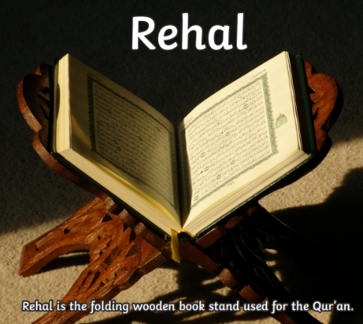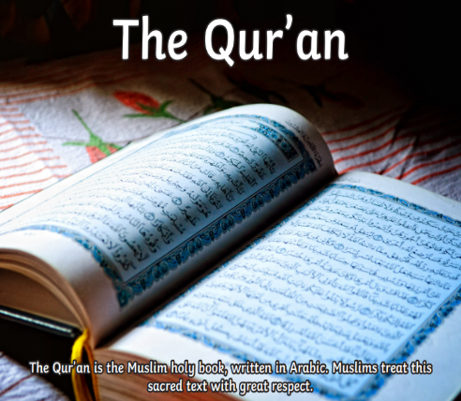

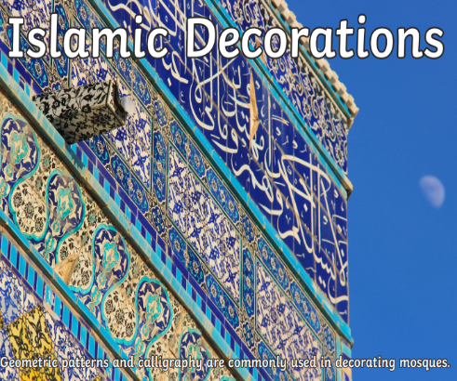

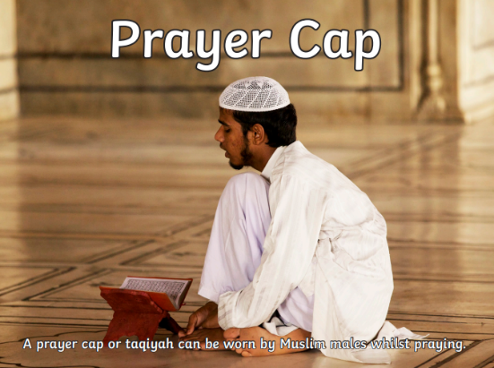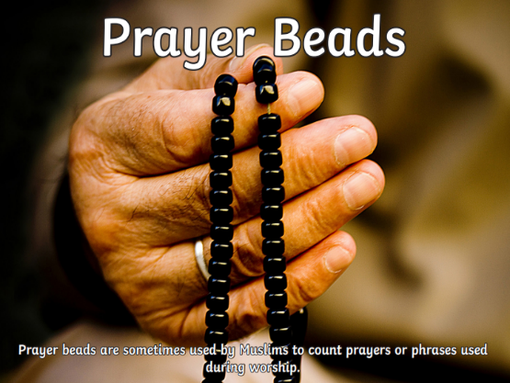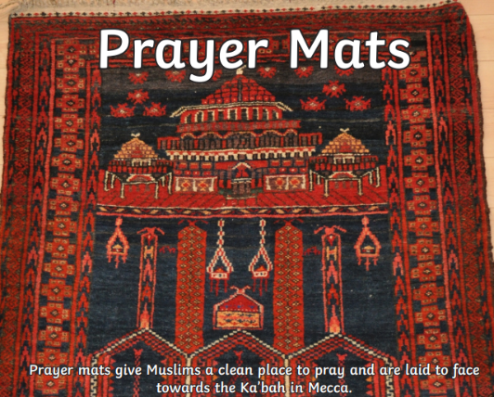

Islam started in Makkah when the prophet Muhammad was chosen by Allah to tell people to live in a way that God would want.

Muslims believe that Allah is

perfect. He is the one who

made human beings.