|  |
| --- |
|  |

|  |  |
| --- | --- |
| bible | The Christian holy book of scripture. |
| trinity | The Father (God), Son (Jesus), Holy Spirit. |
| genesis | The first book of the Bible. |
| Creation Story | The Christian belief of how the world was made. |
| Old and New Trestament | The two main parts of the Bible: before Jesus and after Jesus. |
| Sacred | Hold and protect. |

**Christianity: What do Christians believe about God?**



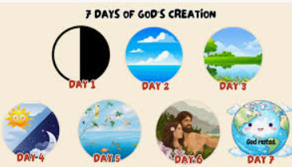

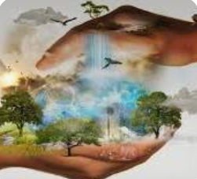

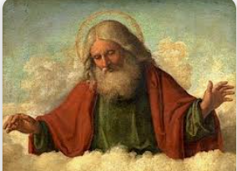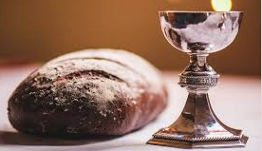

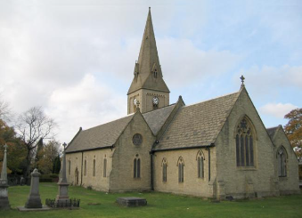

***‘***Love the Lord your God with all your heart and with all your soul and with all your mind and with all your strength.’

The second is this: ‘Love your

neighbour as yourself.’

There is no commandment

greater than these.”*Mark 12:30-31*



