Tatams Class Core Books

Tatams Class have ten ‘core books’ which we want our children to know well by the time they leave the EYFS. These books are the type of books that can be re-visited again and again, on different levels to support language development. The idea is that children will develop language and increase vocabulary in addition to gaining a love of books and will become very familiar with these known texts so that they can remember and re-tell them. We have chosen fun, repetitive books, which are easy for the children to join in with, so that the experience of reading becomes interactive and the children begin to learn the story as they are read to. In each book there is lots to discuss so that the children understand the vocabulary as well as what is happening.

All of our core books have pictures, which support the text but also compliment and add to it. We discuss the pictures and what is happening in them as much as the text. We find our children learn the books word for word after a while, which can give them great confidence as early readers in terms of fluency when reading.

The Three Little Pigs | We’re Going on a Bear Hunt | Owl Babies | Tiddler | Peace at Last
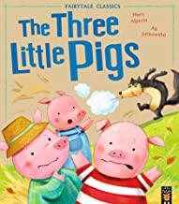 | 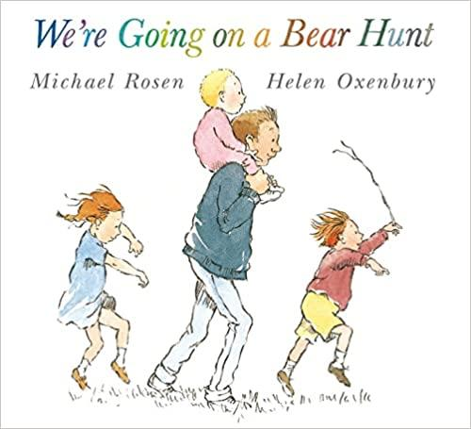 | 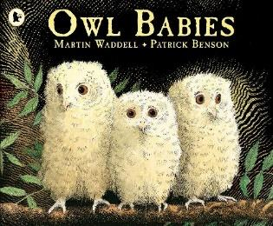 | 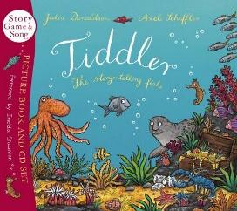 | 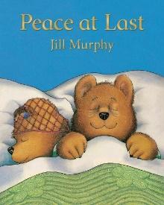
The Naughty Bus | Room on the Broom | Mr Wolf’s Pancakes | Landy | Handa’s Surprise
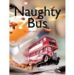 | 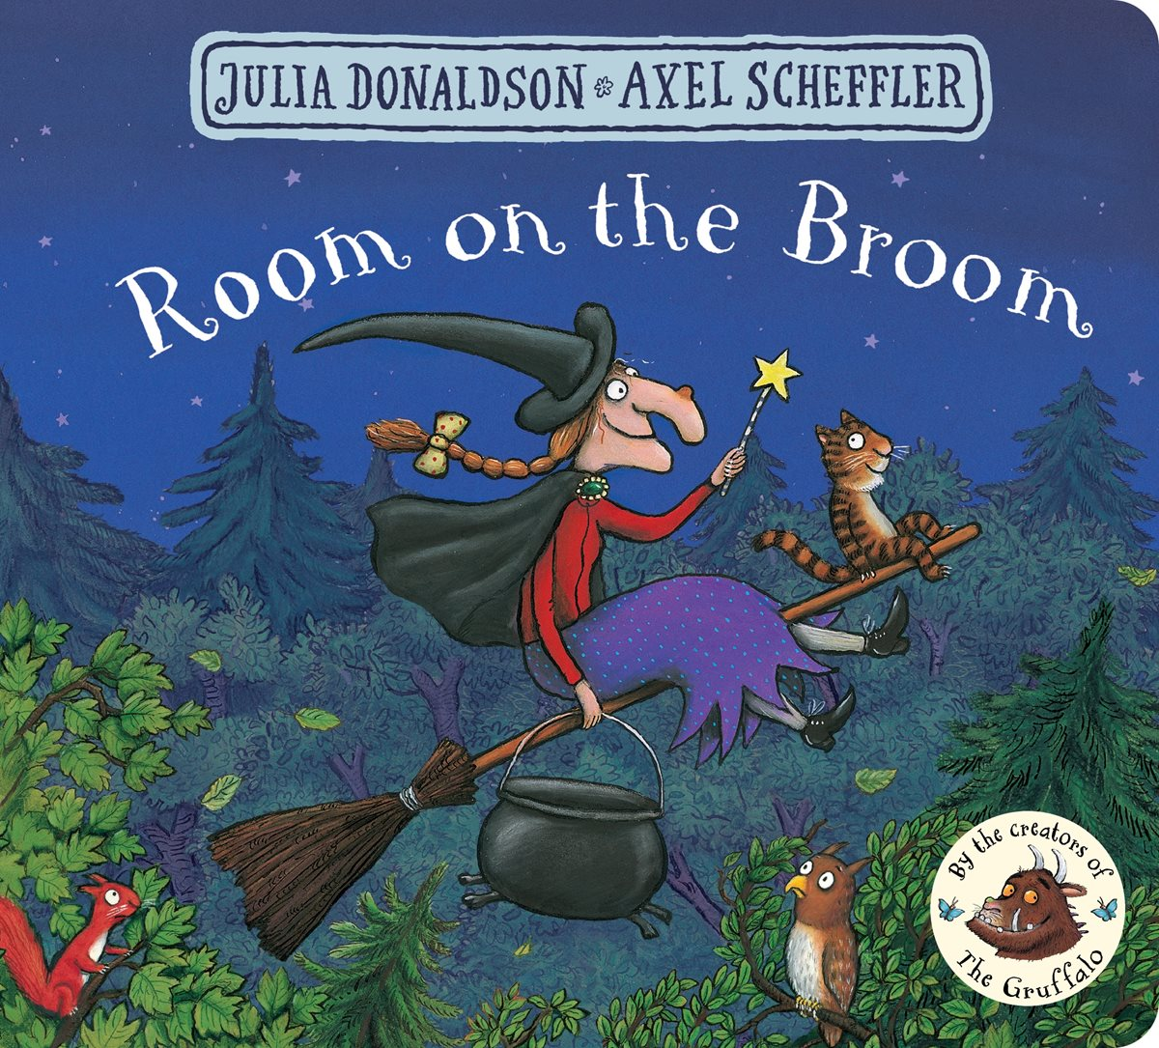 | 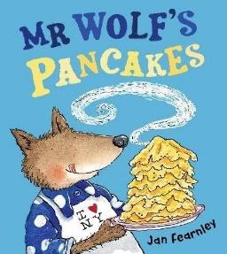 | 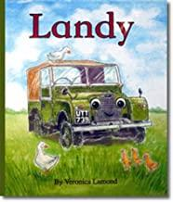 | 