|  |
| --- |
|  |

|  |  |
| --- | --- |
| Samaritan | A person from Samaria, a country near to where Jesus was teaching |
| Levite | A legal expert who would have known that it states in the law that he should help an injured man. |
| Pharisee | A Jew who always keeps to the rules and scriptures. |
| Parables | Stories that Jesus told to illustrate points he was trying to make in a way (or setting) that his listeners would understand. |
| Holy trinity | God, the Father and the Son. |
| The Bible | Holy book divided into the Old and New Testaments. |

**Christianity: Is it possible to be kind to everyone all the time?**



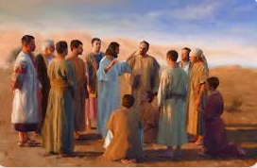



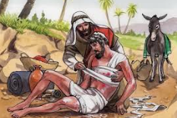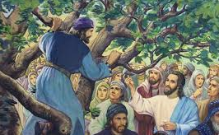

Zacchaeus was a tax collector for the Romans so would have already been unpopular, but was more so because people believed he took more than he needed.



***‘***Love the Lord your God with all your heart and with all your soul and with all your mind and with all your strength.’ The second is this: ‘Love your neighbour as yourself.’ There is no commandment greater than these.”*Mark 12:30-31*